“RUTOPIA 2”

Daria Tsoupikova
School of Art and Design
Electronic Visualization Laboratory (EVL)
University or Illinois at Chicago
106 Jefferson Hall (MC 036)
929 Harrison St.
Chicago, IL 60607
USA
datsoupi@evl.uic.edu
http://www.evl.uic.edu/animagina/rutopia/rutopia2/index.html

Abstract

"Rutopia 2" is a virtual reality art project built for the C-Wall network environment.
It describes a magic garden with interactive sculptural trees that connect to distant worlds and unites them into a shared network community. "Rutopia 2" explores the aesthetics of virtual art inspired by the distinct cultural forms present in Russian folk arts and painting. It is based upon their principles of composition, bright colors, simplified shapes, and material culture.

1. INTRODUCTION
The quality of the graphics and the aesthetics of the virtual world can be made to evoke certain emotional changes in the user’s state of mind. These changes and effects on the user can be produced by adapting forms from traditional arts such as painting, sculpture, design, education and music to create a higher quality sense experience in a virtual environment. Sophisticated colouring and textures, special effects, interesting animations, original 3D models, well designed compositions of the virtual spaces, and dynamic user interactions characterize internationally famous virtual art projects. “Rutopia 2” strives to capitalize on the immersive power of aesthetics to impact user’s emotions with a unique visual atmosphere morphing into the memorable virtual experience.

2. “RUTOPIA 2”

2.1 Concept
Virtual reality art project “Rutopia 2” explores the relationship between aesthetics of virtual art, painting and Russian folk arts, such as wood sculpture, traditional toys, and decorative painting. The project depicts a magic garden with interactive sculptural trees that connect to distant worlds and unites them into a shared network community. The tree structures combine Russian folkloric forms with futuristic designs while being based on a singular module - a rectangular screen. Their shapes transform through rotations or flips, put together or taken apart in different ways, similar to a tangram puzzle [1]. I view the animation of these dynamic tiled trees as an attempt to break through the static flatness of the contemporary tiled-display grids, architectural facades, and surfaces into the perpetually changing 3D sculptural forms. The trees are the prototypes of the interdisciplinary public portals that combine architectural, tele-immersive, educational, and artistic ideas with social functionality into a communal hybrid. Their organic movements embodied through mathematical calculations and interpolations depend on the user’s interaction with the environment and his or her proximity to the trees. The garden explores the interactive symbiosis between man, nature, and technology and visualizes an unattainable world of harmony inspired by folk utopian idealism and futuristic design.
When the visitor enters the virtual space he/she sees a greyscale world with a small island surrounded by a river. To enter the island, visitors can use one of the two bridges across the river. There are three color areas on the island. Upon the user’s approach those areas will automatically grow the trees “planted” inside (Fig. 1, 2). Once fully grown, the screens turn into windows and show views to other worlds. The island mode changes from the greyscale to multicoloured (Fig. 3). The screens of the trees convert to the portals that link to remote worlds. Virtual visitors can look through the screens to see distant environments just like we can look through a window and see the outside (Fig. 2, 4). The details of the remote worlds depicted on the screens of the trees in high resolution. By moving through the screens users can view and enter the remote environments. Each tree is a portal to 30-50 remote worlds which users can visit by walking through the screens. Visitors can also communicate with each other and explore the remote world with a traditional log house from folk stories. Virtual screens cross traditional borders of segregated realities to link in real time the present, past, and future as well as the close and the distant. At the current stage of development the project presents three virtual worlds, the island, the house, and the connecting tunnel. Potentially, each screen in each of the trees could be linked to the different remote worlds therefore organizing the web of the remote environments.

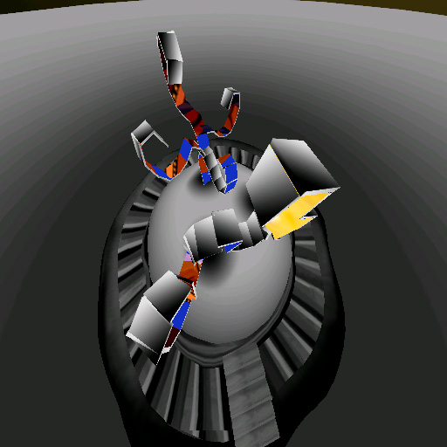 | 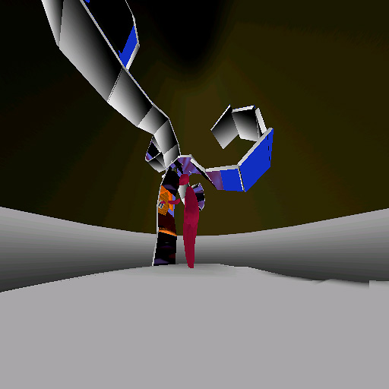
Figure 1. The Island world with the growing trees. | Figure 2. The visitor is looking through the screens to see the details of the remote world.

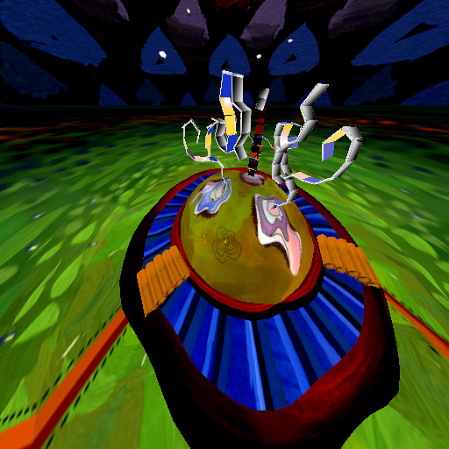 | 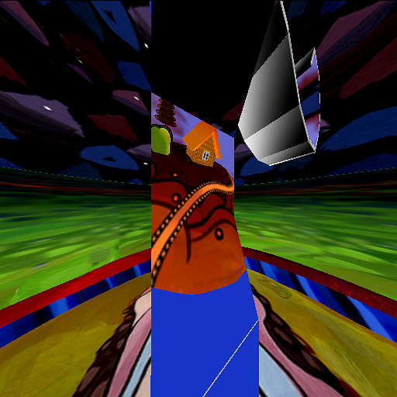
Figure 3. The island changes the mode from greyscale to multicoloured. | Figure 4. The details of the remote world seen through the screen in high resolution.

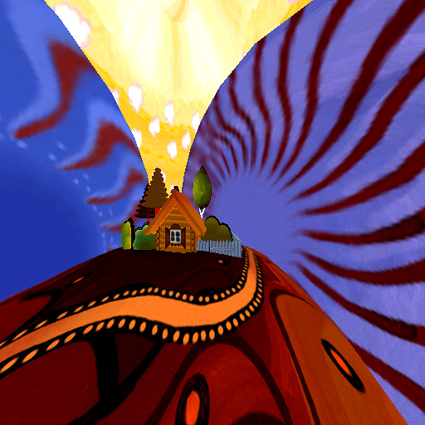 | 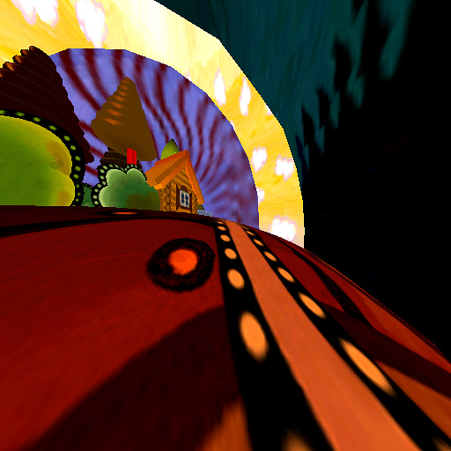
Figure 5. The remote house world. | Figure 6. View from the tunnel back to the house world.

2.2 Emotional experience and aesthetics
Virtual Reality (VR) art relies upon both traditional and digital art forms such as painting, sculpture, music, film, photography, computer graphics, animation, design, installation, and others. In many aspects VR is the ultimate host and medium for all other art forms, not only traditional but also digital. It contains elements of computer graphics, animation, design, installation, sculpture, architecture, music, film, and photography from the visual, performing, and spatial arts. These developmental principles derive from traditional art forms; textures from painting and photography, 3D models from sculpture, animation from film and time-based arts, sound from music, composition and space organization from architecture. The interaction of technology with aesthetics is the nexus which provides connection between digital and traditional arts in the virtual environment. Empowered by other art forms VR has a potential to offer the ultimate aesthetic experience on demand.
According to the Dynamical Psychology, the more harmonious, beautiful, and unique the aesthetics, the stronger the emotional experience of the user [2]. Harmonious colors, carefully designed shapes and well organized time-based compositions create a sense of balance and order and induce emotional responses. Through motion, touch, feel, hearing, and sight VR gives the opportunity of the profound experience of another reality. VR has the potential for the ultimate psychological affect on the user because it relies upon the union of traditional and digital aesthetics.

2.3 Aesthetics and influences
The fairy world of harmony in “Rutopia 2” derives its aesthetic forms from Russian folk arts and crafts such as Palekh, Khokhloma, Dymkovo toys, Fedoskino and Lubok. Those styles, named after the best-known Russian regional centres of art, are famous for superb workmanship, the diverse methods and techniques used, their distinctive features, and the narratives – mostly fairy-tales – on which they are based. Very decorative – with simplified shapes, bold designs, and bright flamboyant colors – each of the styles was developed in a specific area which dictated the ornamental patterns, color palette, and choice of materials. Their crisp easily recognizable style of expression is characterised by generalized outlines, crisp emphasized details, original color schemes, subjects, materials, and forms. They convey the ideas of harmony, beauty, and fantasy with emphasis on the ideal (Fig. 7) [3, 4]. “Rutopia 2” generalizes those aesthetic principles and transmits their culture into VR.

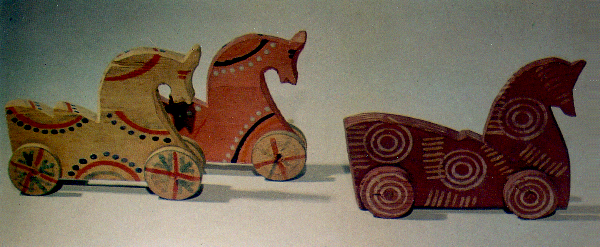
Figure 7. The example of decorative Russian wood toys. Horses on wheels [5].

The home of the Dymkovo toys is a small town on the bank of the Viatka river across from Kirov. These toys were produced during the autumn and winter months from the clay native to that area. These clay figures were formed, dried for a few days in the open air, burned in a kiln, whitewashed with a solution of chalk and skimmed milk and painted with distempered egg yolk paints. Historically, these toys were sold at country fairs and were inspired by pagan religious gods and mythological characters.
Dymkovo toys have very simple rounded shapes and silhouettes. They are painted in bright ornamental patterns with brilliant magenta, green, yellow and blue against a
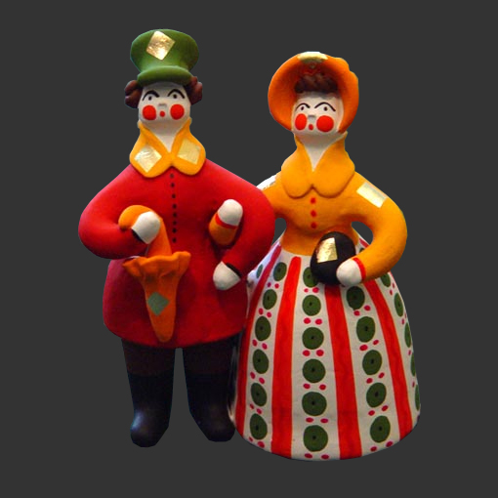 | 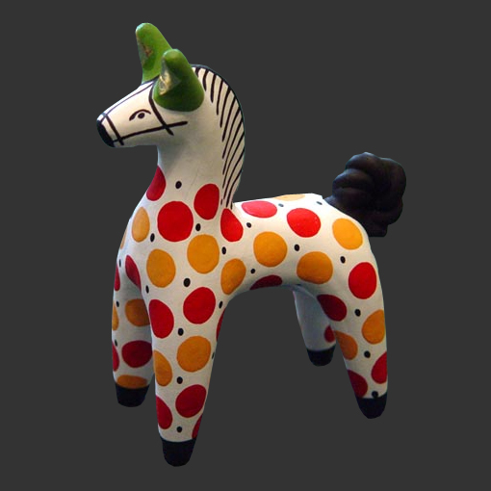
Figure 8. Dymkovo toy “Couple”. | Figure 9. Dymkovo toy “Horse”.

white background. The antique traditions of Dymkovo come to life in the figures of people, animals, birds, and household items (Fig. 8, 9).
The Khokhloma style is recognized for the golden background where the gold effect is achieved without gold actually being used. Palekh craftsmen succeeded in evolving a highly original painting style, making expert use of the decorative black background, gracefully shaped expressive figures, sophisticated color schemes, and refined ornamental patterns. Zhostovo hand-drawn flowers from the Moscow suburb are unique and famous throughout the world for their color and beauty. Zhostovo artists used a special double brush technique to paint on a variety of objects, including the most famous large Zhostovo metal trays.
The aesthetics of “Rutopia 2” is based upon their principles of composition, bright colors, simplified shapes, and material culture. The aim was to create a virtual world with magic atmosphere communicating harmony and balance to affect the emotional experience. Virtual aesthetics helps to provide the mental and spiritual escape from everyday reality into a magic niche while maintaining aesthetics principles of the previous centuries.

2.4 Storyboard sketches
“Rutopia 2” started with hand-painted storyboard sketches inspired by Russian folk arts and crafts. Gouache and watercolour were used to paint details of the island world and the house in the one of the remote worlds. The sketches were painted with consideration of the future development and interaction techniques. The original storyboard is the model for the final virtual environment with the exception of several details. All elements of the future VR world – trees, house, island, bridges – were first designed and planned on these storyboard sketches (Fig. 10, 11). The storyboards also set up the color palette, feel, and look of the VR environment’s composition and virtual space layout. The storyboard sketches and interaction script provided the reference for the development of the scene graph.
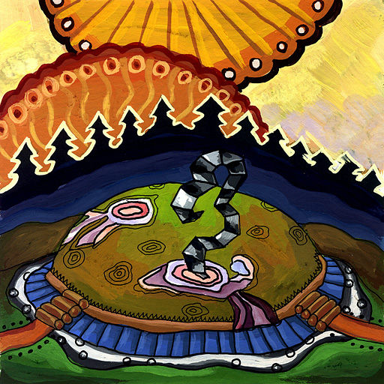 | 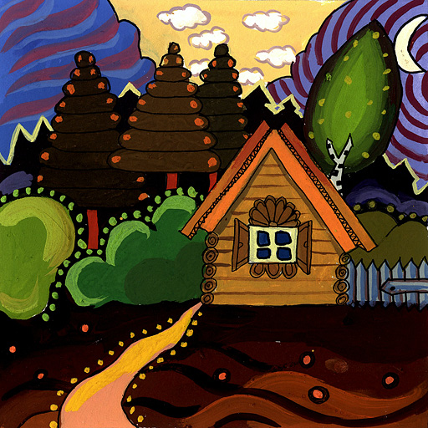
Figure 10. Storyboard part 1. | Figure 11. Storyboard part 2.

2.5 Development
The visual impression in VR depends much on the 3D models and textures. Today, with the growing realism of computer graphic techniques, artists have powerful opportunities to depict realistic impressions and imaginary themes. 3D design packages, such as Maya, provide various techniques for creating unique painted textures for models such as real-time 3D/2D painting and 3D texture synthesis inside the 3D scene. These techniques enabled smooth integration between initial storyboard sketches, the development stage, and the final design of “Rutopia 2”.

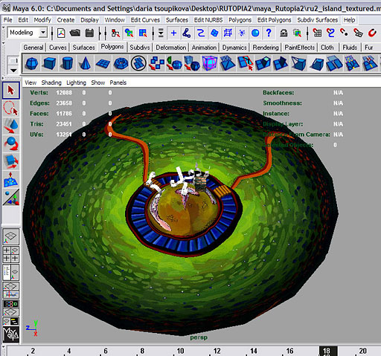 | 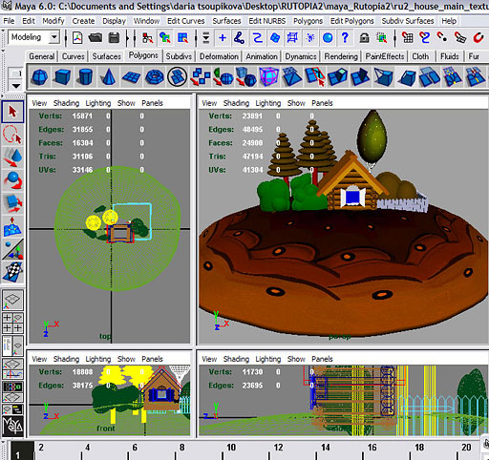
Figure 12. Work in progress in Maya. Screenshot from the island scene. | Figure 13. Work in progress in Maya. Screenshot from the house scene.

“Rutopia 2” was built using Ygdrasil [6], Bergen sound server, OpenGL Performer and the CAVE library. The visitor is tracked from the stereo glasses and hand wand tracker. Skype is used for audio communication between remote avatars through the network during the networking demonstrations. The 3D models based on the storyboard visuals were built using 3D Paint tool in the Maya package. The details of the decorative ornamentation were simply painted inside the 3D scene and then exported as models with textures (Fig. 12, 13). Other textures were individually painted, scanned, and applied on the 3D objects using traditional techniques.

2.7 Interaction
The interaction in the project emphasises the intuitive exploration without preliminary instructions familiarizing the user with virtual environment and it’s rules of exploration. It is based on the participant’s proximity to responding objects and interactive areas. Participants control the direction of the movement and interaction with the objects by using only a wand interface and no buttons.
The screens/windows of the trees were made possible by using the new Ygdrasil node StencilBuffer. The StencilBuffer node works as a mask covering the areas outside the windows so that only the selected window area allows a view to the other world. The other world consists of both distant and close parts. The distant part is the remote place which the visitors enter through the screen. The close part next to the window is covered by the StencilBuffer mask. The visitors can see only the portion of it through the hole of the window. At the current stage of development each third window hole on the tree is connected to the same view of the remote world using alternating repetition. Participants can recognize and visually connect lower and upper parts of the remote house world projected on the different windows to get a broader observation of that remote world. The future interaction in the project is planned to customize the virtual experience for each visitor. For example, as a visitor moves, his/her speed adjusts to the changes in the environment as he/she passes through. Another example could be the changes of the color scheme which depend upon visitors’s interaction with the events and objects.

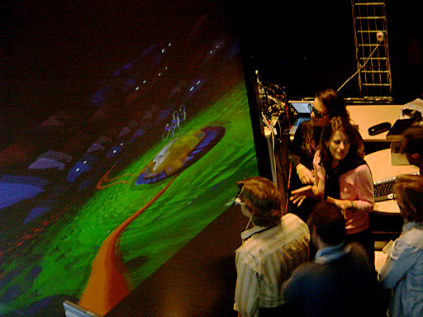 | 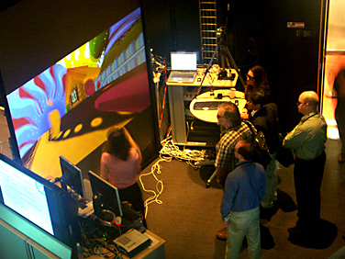
Figure 14. Presentation of “Rutopia 2” at the IGRID2005. Island world. | Figure 15. Presentation of “Rutopia 2” at the IGRID2005. Remote world.

2.8 Network
This project was build to establish a virtual network collaboration between Moscow, Chicago, and San Diego. The first network presentation of the project was held at the IGRID2005 Conference, Calit2, University of California, San Diego in collaboration with the Geophysical Center of the Russian Academy of Sciences (GC RAS), Moscow, Russia (Fig. 14, 15). The C-Wall system was used at the conference site while the Moscow team used the CAVE simulator mode. The network used CAVEwave/National Lambda Rail connection between San Diego and Chicago sites, SurfNet connection between Chicago and Amsterdam sites, and GLORIAD connection between Amsterdam and Moscow sites.

3. SUMMARY
The concept and the development of the “Rutopia 2” relies upon the union of traditional and digital aesthetics and explores the potential of their psychological affect on user emotions. The aesthetics frames the magic of the virtual environment by presenting a coherence that enables the unique creative freedom of design and experience of the virtual reality.

ACKNOWLEDGEMENTS
I would like to acknowledge Alex Hill for technical expertise and constant support. Special thanks to Helen-Nicole Kostis for the help at the IGRID2005 Conference presentation.
The Electronic Visualization Laboratory (EVL) at the University of Illinois at Chicago specializes in the design and development of high-resolution visualization and virtual reality display systems, collaboration software for use on multi-gigabit networks, and advanced networking infrastructure. This material is based upon work supported by the National Science Foundation (NSF), awards CNS-0224306, CNS-0420477, OCI-0229642 and OCI-0441094, as well as the NSF Information Technology Research (ITR) cooperative agreement (OCI-0225642) to the University of California, San Diego (UCSD) for "The OptIPuter." EVL also receives funding from the National Institutes of Health, the State of Illinois, the Office of Naval Research on behalf of the Technology Research, Education, and Commercialization Center (TRECC), and Pacific Interface on behalf of NTT Optical Network Systems Laboratory in Japan. Any opinions, findings, and conclusions or recommendations expressed in this publication are those of the authors and do not necessarily reflect the views of the funding agencies and companies.
The CAVE, ImmersaDesk and ImmersaDesk2 are registered trademarks of the
Board of Trustees of the University of Illinois.
The Personal Augmented Reality Immersive System (PARIS), GeoWall, GeoWall2,
Personal GeoWall2 (PG2), Varrier, LambdaVision, Wanda and CAVELib are
trademarks of the Board of Trustees of the University of Illinois.
For further information see
http://www.evl.uic.edu/

References
[1] A Chinese puzzle consisting of a square cut into five triangles, a square, a
rhomboid, to be reassembled into different figures.
[2] Goertzel Ben, Allan Combs, Mark Germine, A General Theory of Emotion in
Humans and Other Intelligences, The title is Mind in Time: the Dynamics of Thought, Reality and Consciousness, Hampton Press, 2004.
[3] Russian wood toy. Xudojnik RSFSR, Leningrad, 1968.
[4] IU Ovsiannikov, Russian folk arts and crafts. Moscow, Progress Publishers, 1967.
[5] Little horses on wheels. 19-20 century. Village of Leskovo, Gorky district. 11.5 by 3 by 13 sm. 11 by 3 by 13 sm. Russian State Museum. Village Pulekh, Nijegorodsky district. The State Museum of Etnography of Nationalities of USSR.
[6] Ygdrasil is a framework developed as a tool for creating networked virtual environments at the Electronic Visualization Laboratory (EVL) at the University of Illinois at Chicago. http://www.evl.uic.edu/yg/overview.html

