The Round Earth Project:
Collaborative Learning in a Virtual World

Andrew Johnson, Tom Moher, Stellan Ohlsson, Mark Gillingham
University of Illinois at Chicago
Chicago, IL 60607 USA
(312) 996-3002 voice, (312) 413-7585 fax
roundearth@evl.uic.edu, www.evl.uic.edu/roundearth

Abstract
The Round Earth Project is investigating how virtual reality (VR) technology can be used to help teach young children that the Earth is spherical when their everyday experiences tell them it is flat. The round earth is exemplary of fundamental concepts that are difficult to teach because they are counter-intuitive to a learner's currently held mental model. VR is used as part of a larger strategy to create an alternative cognitive starting point where the concept can be established on its own before it is brought into contact with the learner’s past experiences.

Keywords
virtual reality, learning environments, collaborative learning, conceptual change

Introduction
Children do not easily grasp that the Earth is spherical, and more importantly the implications surrounding this fact; their everyday experience reinforces their deeply held notion that the Earth is flat. A rich body of literature demonstrates that children often react to the assertion that the Earth is round by forming blended mental models conditioned by their prior experience. Many construct a mental model of the Earth as a pancake, or a terrarium-like structure with people living on the flat dirt layer inside. Others construct distinct multiple models such as a dual model with a spherical Earth and a flat Earth coexisting simultaneously.
The Round Earth Project is a collaboration among researchers in computer science, education and psychology investigating two Virtual Reality (VR) based pedagogical strategies for teaching children that the Earth is spherical, and the implications of that fact. One strategy, the displacement approach, teaches the concept in an alternative setting free of pre-existing biases, and then relates that learning back to the Earth. VR is used to simulate a small diameter asteroid upon which the learner may walk on a body with a curved horizon, see objects ‘appear’ from ‘below’ the horizon, and take a long walk around the entire globe and come back to where they started. The other strategy, the transformationalist approach, attempts to teach the concept by modifying the children's current mental models. Here VR is used to simulate the launching of a spacecraft from the Earth's apparently flat surface and subsequent exploration while orbiting the planet. In both environments, distributed VR technologies are used to provide a collaborative learning environment promoting positive interdependence among pairs of learners.

Deep Learning
Underneath the extensive systems of domain-specific knowledge that a person brings to bear on problems, there are organizing concepts - fundamental ideas - that influence how both direct experience and discourse within that domain are conceptualized. Such deep ideas form the core of entire systems of knowledge [1]. Fundamental conceptual change encounters a peculiar paradox. The ideas that underpin advanced understanding are typically more fundamental than the ideas a novice learner brings from prior experience [2]. This helps explain the puzzling observation that although many deep ideas can be stated in less than a page of text, systematic attempts to teach them fail with alarming frequency [3]. When instruction attempts to communicate a concept that is both different from, and more fundamental than, the learner’s existing ideas, a paradox occurs. Although the intent is to replace the learner’s existing ideas, those existing ideas are the learner’s only tools by which to acquire the new idea. The typical outcome is distortion: the novel idea is misunderstood in the process of being assimilated to prior knowledge. This is the learning paradox [4].
A simple and compelling example of this effect has been documented by Nussbaum, Vosniadou and Brewer [5,6,7]: Young children tend to believe that the Earth is flat. More precisely, their mental model of the world separates ‘sky’ and ‘earth’ into two parallel layers, one ‘above’ the other; the two directions ‘up’ and ‘down’ are absolute. Empirical studies have demonstrated that telling young children that the Earth is round does not cause their intuitive model to be replaced by a spherical conception of the Earth. Instead children assimilate the new information into their prior knowledge and conclude that the earth is flat and circular.
Children's intuitive model of the Earth is natural because it is strongly supported by everyday experience. Discourse has little impact, not only because words like ‘round’ are ambiguous but also because talk about the Earth is abstract and cannot compete with the vividness of looking upwards when looking at the sky or seeing the ocean with its straight horizon. Pictures have little impact because they require a complex mapping between experience and the 2D plane. To understand a picture of a person on a spherical body, the viewer must project himself or herself into the picture, a cognitive capability beyond very young children. The same is true of a 3D representation such as a globe. However, in VR the children can be immersed in the experience if walking on the spherical surface of a small planetary body such as an asteroid.

Circumventing the Learning Paradox
If the learning paradox is real, how is anything new ever learned? A transformational account assumes that new knowledge is created via operations on prior knowledge. Researchers from Piaget to Karmiloff-Smith have tried to explain cognitive development in terms transition mechanisms, however there is no widely accepted description of a developmental transition mechanism. Any transformational account of cognitive change assumes the existence of powerful transformations that can traverse the space of possible conceptualizations without search.
In contrast, a displacement account of cognitive change assumes that new understanding of a domain or phenomenon begins by establishing an alternative cognitive starting point. A concept is established outside the learner’s existing system of domain knowledge. Initially, such an alternative representation might be rudimentary, and hence be completely dominated by the prior, well-established representation. However, over time, all available representations compete, and a useful representation gradually gains strength and might eventually displace the previous representation. The existence of a compete / evaluate phase allows displacement theories to postulate weaker and more plausible operations on prior knowledge than those required by a transformational account.
The displacement framework suggests a particular instructional strategy for supporting deep conceptual learning: fundamental ideas which contrast with the learner’s current ideas need to be established on their own terms before they are brought into contact with the learner’s prior ideas. A new idea should not be taught by directly confronting or transforming the learner’s current idea, but by establishing an alternative knowledge structure or representation, a cognitive seed out of which a deeper understanding of the relevant domain can grow. VR, we believe, provides a powerful tool in helping to create such alternative cognitive starting points.
Although crucial, this instructional strategy is not enough. The alternative representation must be brought into contact with the learner’s prior knowledge of the domain. Unless learners eventually bring their experience in the displaced domain into contact with everyday experience in the target domain, the learning objective is not reached. The point is not just to know what it would be like to walk on a spherical planetary body, but to understand that the Earth is such a body. We call this second step bridging activities.

VR and Learning
Research in conceptual learning in virtual reality is a relatively young field, but growing rapidly. In a recent report by the Institute for Defense Analysis, Christine Youngblut comprehensively surveys work over the past few years in the area, citing approximately 50 VR-based learning applications, and 35 studies which include desktop but exclude text-based virtual environments [8]. We believe that VR offers potential benefits for some kinds of learning goals. However, the high costs of investigation in this domain impose special responsibilities on researchers. At the least, we believe that research in VR and learning should be directed toward learning problems with the following characteristics:

1. The learning goal must be important. That is, it must be identified as a component of adult scientific ‘literacy,’ as reflected in national standards or benchmarks (e.g. those published by the National Council of Teachers of Mathematics or the American Association for the Advancement of Science Project 2061 Science for all Americans report.) AAAS Project 2061 states that sixth graders should know “things on or near the Earth are pulled toward it by the Earth's gravity” and that “the Earth is approximately spherical in shape.” Ninth graders should know “everything on or anywhere near the Earth is pulled toward the Earth's center by gravitational force.”

2. The learning goal must be hard. That is, it must be reflected in the literature of researchers and / or practitioners as difficult to effect and resistant to conventional pedagogical strategies. The existing literature by Vosniadou, Brewer and Nussbaum discuss the difficulty of this learning problem.

3. The learning goal must be plausibly enhanced by the introduction of immersive virtual reality technologies. Immersive VR is well suited to giving a person the sense of walking on a spherical object with small diameter, seeing objects ‘appear’ from ‘below’ the horizon and returning to the starting point after circumnavigating the sphere.

4. Finally, VR-based learning environments must be informed by contemporary research in the learning sciences and educational practice. The environments designed in this project emphasize role differentiation with positive interdependence and collaborative learning.

Asteroid World & Earth World
We created two worlds to compare the displacement and transformational approaches. For the displacement approach the children start off at an alternative cognitive starting point: a small asteroid. Here they can learn about walking around a spherical body different from the Earth. For the transformational approach the children start off on the Earth and attempt to transform their current Earth model into a spherical Earth model.
We wanted the children to see both a spherical representation of the planetary body as well as the ‘flat’ view from the surface and be able to integrate these two views. Because of this we made the world collaborative, with one child experiencing the surface of the world and the other seeing the avatar of the first child on the spherical world. We wanted to give the kids a task to perform so that the child on the surface needed to move around the spherical body. This way one of the participants would often be ‘upside down’ on the sphere but ‘right side up’ on the surface. We wanted the collaborative task to foster positive interdependence where neither child could perform the task alone; they would need to cooperate and communicate with each other. Through this communication the children would need to reconcile their different views. We wanted the controls to be simple so there was little training time involved and the children could concentrate on the experience. Finally, we wanted to keep them engaged, giving them a long enough experience to grasp the concept but not so long that they became fatigued.
In both worlds the children are given the task of finding ten objects scattered around the planetary body. The roles of the two children are ‘the Astronaut’ and ‘Mission Control’ and each child performs both roles during the experience. The astronaut moves around the planetary body collecting each of the parts, guided by the child in mission control. Mission Control sees a spherical view of the planetary body, as seen from an orbiting satellite, and can see the location of each of the ten objects. The astronaut experiences this shared virtual world from a CAVE, increasing his / her sense of immersion; mission control uses an Immersadesk to monitor the 3D planetary body. The generic controller for the CAVE and the Immersadesk is the ‘wand’ - a six degree-of-freedom mouse with three buttons and an isometric thumb-controlled joystick. In the CAVE with the astronaut, the left button turns the child to the left, the middle button moves forward, and the right button turns to the right. In order to pick up an object, the child simply needs to get within 5 feet of the object and it is automatically grabbed. At the Immersadesk with mission control, the joystick is used to spin the world. The world can be turned completely around horizontally with limited tilt of the world. This allows mission control to keep the astronaut in view at all times, but allows the astronaut to be ‘right side up’ in the Northern Hemisphere, ‘sideways’ near the equator and ‘upside down’ in the Southern Hemisphere.

In the Asteroid world, the two children find themselves marooned on the surface of a small asteroid and they need to retrieve ten fuel cells from the surface and bring them back to the ship. The astronaut starts out in the airlock of the marooned spaceship and has ten minutes to explore the surface in search of the fuel cells. The child can carry up to four cells and then must return to the ship to drop them off. Mission control sees the astronaut as a person in a spacesuit walking on the surface of the asteroid. After ten minutes, the astronaut is automatically teleported back to the ship. The children then switch roles. When both have had their time on the surface they are told that they successfully completed their mission and they both stand in front of the Immersadesk to see their spaceship liftoff from the surface of the asteroid and begin their journey home. Figure 1 shows what the astronaut sees in the CAVE. Figure 2 gives a closer look at what mission control sees. This view shows the spherical asteroid with the avatar of the astronaut moving about the surface as well as the view from the CAVE of the astronaut moving on the surface.
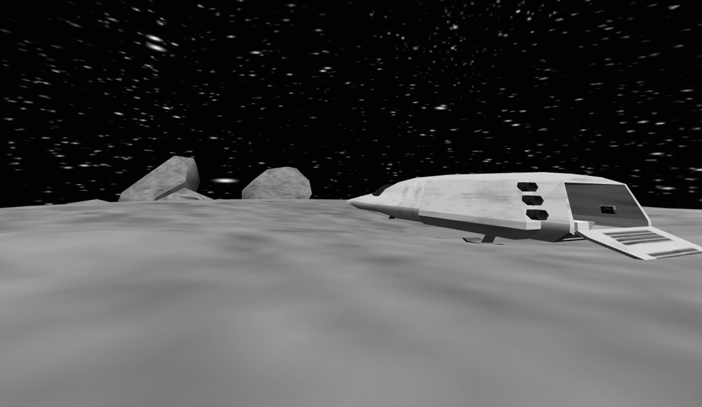

Figure 1. The astronaut / CAVE view of the asteroid. In the Asteroid World, the astronaut explores the surface of the asteroid within the CAVE, starting from the space ship sitting at the North Pole. The astronaut, guided by Mission Control, moves around the surface collecting fuel cells.

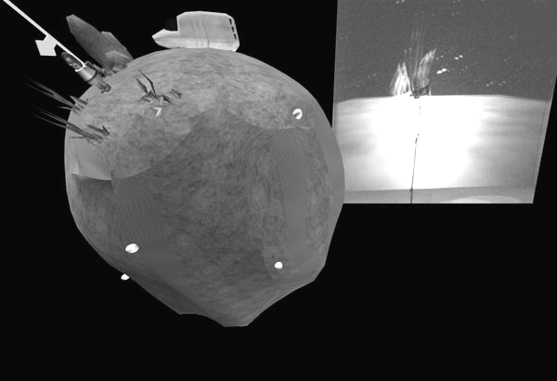
Figure 2. The Mission Controller / ImmersaDesk view of the asteroid. The mission controller simultaneously sees the avatar of the astronaut moving around the spherical asteroid and the view from the astronaut's perspective of the slightly rounded surface of the asteroid

In the Earth world, the two children must retrieve ten parts from a broken satellite scattered in orbit around the Earth and bring them back for re-assembly. The astronaut sits in the command chair of a spaceship on a launching pad surrounded by the skyscrapers of downtown Chicago. Since our young learners are from Chicago, this gives them familiar starting point on a very flat looking Earth. As the engines roar, the astronaut is then launched into space. The astronaut sees the buildings, then the city, then the Earth fall away as he / she rises into orbit to see an Earth with a curved horizon. Once in orbit the astronaut maneuvers the ship close to the satellite parts so that they can be retrieved. Mission control sees the astronaut's pointy space capsule flying over the surface of the Earth. After ten minutes the autopilot engages, maneuvers the ship back over the city of Chicago, and the ship lands back on the launch pad. The children then switch roles. When both have had their time in orbit they are told that they successfully completed their mission and they both stand in front of the Immersadesk to see the satellite that has been reconstructed. Figure 3 shows what the astronaut sees on liftoff. Figure 4 gives a closer look at what mission control sees. This view shows the spherical Earth with the astronaut's spaceship orbiting above the surface as well as the view from the CAVE out the front window of the orbiting ship.
The astronaut in the CAVE wears a pair of Stereographics glasses to mediate the stereo imagery containing a position sensor for the Flock of Birds tracker, and carries the standard CAVE wand. The astronaut's speech is picked up via an ambient microphone mounted on the top of the front wall of the CAVE. Audio from the application and from the mission control are mixed and sent through the CAVE's four speakers. A low light color CCD camera mounted outside the entrance to the CAVE sends the image of the astronaut and the front CAVE screen into the computer for the Immersadesk and into the VCR for recording.
Mission control at an ImmersaDesk wears a pair of Stereographics glasses to mediate the 3D images, but mission control is not head tracked. This was done so that the 3D image of the spherical planet would always be completely on the screen, no matter how active the child was. The camera image from the CAVE is placed onto the Immersadesk screen next to the spherical view. Mission control's speech is picked up via a head-worn microphone. Audio from the application and from the astronaut are mixed and sent through the Immersadesk's two speakers. A low light color CCD camera mounted behind the child sends the image of mission to the VCR for recording. Audio from both the CAVE and Immersadesk microphones are also sent to the VCR.

User Studies
To date, we have conducted three pilot user studies. The first study consisted of four pairs of children, looking primarily at interface and usability issues in the two worlds. The second study consisted of eight pairs of children concentrating on learning in the two worlds, the effectiveness of the bridging activities, and the ability of the pre- and post-testing to reflect change in the children's models. These led to changes in our procedures; a third pilot study of five pairs of children in the asteroid world was undertaken to evaluate our modified design.
The children came from a small urban Chicago public school where the third grade students score significantly below the state and district averages in reading and math and below the state average in writing. In the first pilot study the children chosen were children of the teachers and administrators at the school, allowing us to familiarize their parents with our procedures. In the second and third pilot studies the children were summer school students who did not pass the Iowa Test of Basic Skills Grade 3 exam. This seemed to be an ideal group for an alternative learning experience.

Pilot Study 1
The first pilot study showed us several things about the usability of the VR worlds. From a hardware point of view, the main problem is that the Stereographics glasses are too big for small children. We still have not found a satisfactory solution to this problem aside from tying the glasses on. Our initial ‘realistic’ asteroid world interface of having the astronaut reach down with their hand to pick up a fuel cell was replaced with automatic grabbing when the astronaut moved close to the cell. This allowed the kids to concentrate on the important task of moving about the asteroid rather than on the unimportant skill of picking fuel cells. The navigation was also simplified from using the joystick to move about the asteroid, to using the three buttons to perform turn left / move forward / turn right which was easier for smaller hands to control. The representations of the astronaut in the Mission Control view were also enlarged to eight times their actual size to make the direction they were facing more obvious. Once these changes were made, the children were very effective in their use of the VR technology, and the application remained virtually unchanged for the rest of the studies.

Pilot Study 2

A great deal of component knowledge is subsumed under the rubric of ‘knowing that the Earth is round.’ We prepared a 16-item questionnaire (inspired by the items used in [6,7]) designed to probe for understanding of the following concepts:

1. The Earth is roughly spherical in shape,
2. There is no absolute ‘up’ or ‘down’ associated with a particular portion of the Earth,
3. The Earth is continuous and can be circumnavigated,
- The horizon is a curved edge that may partially or totally occlude objects on the other side (or in space).

We conducted individual oral pre-test interviews based on the questionnaire lasting 15-20 minutes at the Chicago public school a day or two prior to their VR experience. Subjects responded to the items with verbal answers, drawings, gestures, and the construction of PlayDoh™ models.
The children were brought in pairs to a university campus, given a cover story describing the scenario, and were given brief training by and adult guide in the use of the VR apparatus. After an introduction by the guides, the children split up, spending ten minutes on each task twice, e.g. one child would be mission control for ten minutes, then astronaut for ten, then mission control for ten, then astronaut for ten. The guides only interfered when absolutely necessary, trying to keep the immersion as strong as possible. The children were very engaged in the activity, and their sense of presence seemed high. Several said that they initially felt they would fall off the world if they walked over the nearby horizon but once they walked over that horizon they became comfortable with moving over the surface. Most of the children were actively talking to each other. Unfortunately, the children seemed too engaged in the task, focusing on the goal of collecting the fuel cells or satellite parts and only conversing on that specific topic. The children treated the experience as a big enjoyable video game, only interested in achieving the goal of the game.
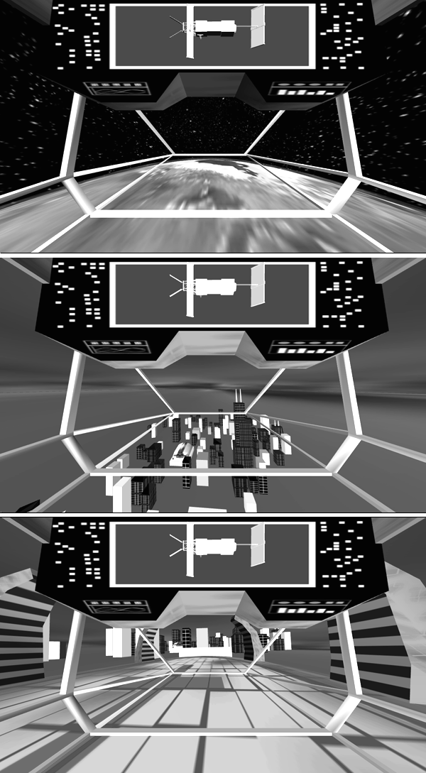

Figure 3. In the Earth world, the astronaut launches from Chicago up into orbit in the cockpit of a spaceship within the CAVE. The astronaut flies around the Earth collecting parts of a broken satellite, guided by Mission Control
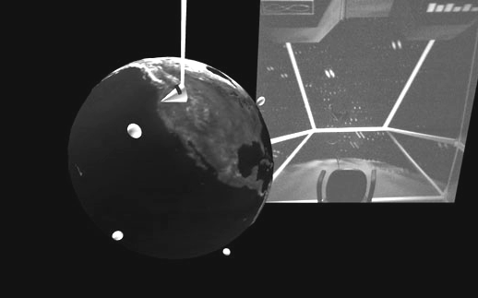

Figure 4. The Mission Control screen for the Earth world. Mission control simultaneously sees the astronaut's spaceship moving around the spherical Earth and the view from the astronaut's perspective of the slightly rounded surface of the Earth.
The two distinct interfaces allowed us to employ a tightly coupled jigsaw collaboration scheme, alternating each child between the two positively interdependent roles of astronaut and mission controller. Upon completion of the task, the subjects were brought together in front of the ImmersaDesk for a bridging activity, and an adult interviewer led them through a brief recounting of their experience using the mission controller view. Each of the four identified knowledge components was reviewed and reinforced in the context of the asteroid, and in each case, the students were told that the same facts applied to the Earth as well, citing similarities and differences between the two celestial bodies. Immediately following the bridging activity, the children were brought to a different room, and interviewed separately using the same questionnaire. Following completion of the assessment, they were taken back to their school.
For each subject, the audio tapes and written documents were reviewed for evidence of learning in each of the four component knowledge areas. The results were disheartening. Where we had hoped that conversation between the children would focus on the apparent contradictions to their daily experience (e.g., “hey, you're upside down,” “no, I'm not!”), the discourse focused almost exclusively on the goal of collecting the ten fuel cells or satellite parts. Among the ten Asteroid World subjects, four began with highly immature models of the Earth's shape and all continued to hold to their naive models in the post-test interviews. The remaining six subjects had indicated a belief in the sphericality of Earth in the pre-tests, but all fell short on one or more of the remaining knowledge components. Among those six, there was limited improvement in the relativity of up and down questions, and in the circumnavigability questions. Still, the robust outcome we had hoped for was obviously missing.
We called a halt to the second pilot study, and considered the factors that may have led to our limited success. We were able to identify numerous potential sources: the design of the application interfaces, novelty effects, learning and attention deficit disorders among our subject pool, social and communications difficulties among subject pairs, and more. We focused on what we believed were the two most important issues: over-engagement in the task at the expense of learning, and the failure to bridge learning about the asteroid to the subjects' mental models of Earth. We decided to call a halt to this pilot study and to make some significant adjustments to our procedures, focusing for the time being exclusively on the Asteroid world.

Pilot Study 3

Since the children were quite able to use the VR hardware and complete the task, we needed some way for them to focus less on the task, and more on the concepts we wanted them to learn. For the third pilot study we modified our approach in several ways.
First, the initial ‘training’ period with the VR apparatus was modified so that the adult guide spent several minutes drawing the subjects’ attention to salient features of the asteroid which reflected the target knowledge components prior to establishing the nominal task goal. Instead of a short training time with the guides focusing exclusively on the VR hardware, the guides now gave each child an individual five minute introduction to the astronaut view and a similar introduction to the mission control view, and then introduced the collaborative task. The guide showed that if you kept going in the same direction that you would return where you started, and pointed out objects appearing over the horizon. We hoped that this would help to overcome the subjects’ overwhelming focus on the task while at the same time serving as an advance organizer for the target knowledge goals. Since the introductory time was increased, the children spent only ten minutes in each role, rather than two sets of ten as in the previous study. While walking the children between the CAVE and the Immersadesk, the guides would try to reinforce the concepts brought up during the training session.
Second, we made a significant change in the bridging activity following the VR experience. We built a feature-faithful Styrofoam model of the asteroid, and purchased a larger commercial Earth globe. In place of the joint ImmersaDesk debriefing, we substituted individual bridging sessions lasting about 15 minutes for each participant. During those sessions, we systematically reviewed each of the knowledge components, using a discussion to relate the subjects’ experience in the VR environment first to the Styrofoam model of the asteroid, then to the Earth globe, citing the analogies between the two physical models. In each case, movable stick-on props and figurines were used to represent VR objects and the participants themselves. While the Immersadesk allowed mission control to see the astronaut moving over the surface of the sphere, the physical models allowed more direct manipulation and interaction between the instructor and the student with the model. The instructor could now position a small astronaut figure at any point the sphere and manipulate the orientation of the sphere. Out of concern that the nature of the revised bridging activity might lead to similarity in the post-test, we delayed the follow-up assessments until the next day, back at the children's school. As it turned out, the discovery nature of the bridging activity itself proved useful in comparing the persistence of apparent learning.
Ten children participated in the third pilot study, drawn from the same subject pool as in the second pilot. There was little direct evidence that the change in the initial training protocol had much effect; the children's dialogues continued to be almost exclusively task oriented. However, unlike the first pilot, there were several success stories. Seven of the children began with pancake model. By the post-test, two if these seven appeared to have adopted a spherical model of the Earth, and a third subject moved to a dual model of Earth in which one component was spherical.

A Case of Conceptual Change
Celandra is a nine-year-old student. During her pre-test, Celandra held that up and down were absolute for all people on the Earth, and made a circular drawing to reflect the Earth’s shape, with people living “all over” the interior of the circle. Her PlayDoh model was pancake-shaped, with people living “only on the top.” Celandra reported that people couldn’t see things far away “because it's too far and it might be cloudy.” She answered the airplane question (If you jump into an airplane and fly in the same direction at the same height for a very long time, how far could you go? Where would you end up if you just kept going and going?) by saying that the airplane would go to the end of the Earth, where it was “very cold and it would be like different people.” An animal could accidentally fall off the Earth, into a “big open space...under the ground.” The sun and moon were sometimes not visible because they “went to another planet” or were “behind some clouds.” Celandra's drawings reflected an absolute notion of up and down.
When asked what she had done in the VR experience, Celandra gave a strictly operational response, describing the number of fuel cells collected and the interaction with her partner. When asked about the shape of the asteroid, she said it was “like a ball” rather than a pancake, and expressed strong agreement that the Styrofoam model was like the asteroid. Celandra said that the space surrounding the Styrofoam model was filled with stars. She indicated that if you continued to walk around the asteroid, “you'd end up back to the space ship again, but on a different side [of the ship].” When asked the same question regarding the Earth, she believed that she would return to Chicago, where she started. Celandra felt that during her VR experience it felt like she might fall off the asteroid, but she didn't, because “it's a round ball,” and that people on the south pole of Earth wouldn’t fall off, either.
During her post-test, Celandra believed that up and down were relative to where you were on Earth, and that ‘up’ in China was not the same as ‘up’ in Chicago “because the earth is like a ball and people who are down up under the earth then they won't fall off.” She pointed over her head when asked where ‘down’ was for people in China. In contrast to her pre-test, Celandra created a sphere for her PlayDoh Earth model, and indicated that people live “up here and down here,” pointing to both northern and southern hemispheres. She couldn’t see where a cannon ball lands on the other side of the Earth, she said, because “it’s blocked. Cuz the earth is just round and it’s like a ball and it’s blocked by the ball.”
Flying straight for a long time in an airplane would take her back to Chicago, she stated, and she would never get to the end of the Earth because “it's a round ball.” People couldn’t fall off the Earth because “people live up and down, and [pointing to the South Pole of her PlayDoh model] down is up for them.” She continued to believe that the moon and the sun became invisible because of clouds or their movement to other planets. The space surrounding her PlayDoh model was filled with “stars,” but the space surrounding her (circular) drawing of Earth was filled with “oceans.” Celandra's drawing’s now reflected a relative ‘up’ and ‘down.’
Celandra appeared to undergo a fundamental conceptual change, from a flat pancake with an ominous ‘end’ to a spherical body where up and down were relative to position. Her model was not perfect—there were still oceans outside her drawing of Earth, and while she understood occlusion for Earth-bound objects, she didn’t use the same reasoning for other celestial bodies. Nonetheless, she appeared to understand that what she had learned about the asteroid also now applied to her Earth as well.

Discussion
These three pilot studies have shown us that the children were able to use the VR equipment effectively. They were strongly engaged by the task, sometimes to the detriment of the target learning, treating the experience like a video game to be ‘won’ rather than a possible source of learning. The children actively communicated with each other, though again on very task-specific topics. Was the VR experience an integral part of the learning for our subjects? For those subjects who appeared to undergo conceptual change, we believe that it was effective in helping to establish an alternative cognitive starting point, as required by the displacement learning model. These subjects found the asteroid a plausible reality, and were able to use their experience to subsequently reason about how things might be on Earth.
But accepting the VR asteroid as plausible was not enough. There were subjects in both pilot studies who appeared to find the asteroid believable did not successfully bridge their knowledge to the target domain. For subjects in pilot study 2, we believe that the fault lay in the abruptness of the intended bridging activity, and that simply telling them that their new knowledge applied to Earth left them too tools with which to bridge between two apparently dissimilar representations. The pilot study 3 subjects who succeeded in changing their concept of Earth did so, we believe, because the revised bridging procedures afforded them a chain of representations from source to target domain, with each new representation being sufficiently similar to its predecessor to be accepted.
VR is good at delivering multiple representations, and in doing so seems an attractive medium for displacement learning. However, if the representations used are too far from the target domain, they run the risk of being viewed as a separate reality. If they are too numerous, they run the risk of overwhelming the learner. We still had more failures than successes in pilot study 3. Perhaps the revised bridging procedure introduced too many intermediate representations, and that the cognitive demands were simply too great for the subjects to handle. It is not new news that transfer of learning does not always occur, and the issue as to when it does occur remains an unresolved problem.
Our discussion has avoided altogether the most decontextualized aspect of the work. We used real school children, but in an unreal setting—a one-shot experience in a university laboratory. We are currently working with teachers at a local public elementary school in planning a multi-year deployment of VR technologies within their established curriculum structure. As a first phase of this long-term deployment, we will be continuing these studies within the school for three weeks. We hope to be able to report more evidence concerning the use of VR and displacement learning based on this experience.
The effectiveness of the two pedagogical strategies, and the value of distributed virtual reality technologies in support of these strategies, remain open questions. We are encouraged that there were clear instances of learning related to specific knowledge components of the target concept, but it is clear that the methods employed to date have not demonstrated clear proof of effectiveness. Nonetheless, we believe that our experience has given us direction for improving our environments, protocols, and analysis strategies. We are currently engaged in refinements of all of these aspects of the project, and we are planning additional iterations of empirical studies for the near future.

Acknowledgements
There are many people involved in this research project. In addition to the authors, the Round Earth team includes Joe Alexander, Tom DeFanti, Josh Hemmerich, Jyoti Jain, Mark Orr, Carlos Orrego, Maria Roussos, and Mike Trolio. We also acknowledge the assistance of Josephine Anstey, Jim Costigan, Tom Frisch, Jason Leigh, Dave Pape, Sam Thongrong, and Fang Wang.
We especially wish to thank Shirley Woodard, Program Director, and Anthony Biegler, Principal of South Loop Elementary School, for their Herculean efforts in encouraging and coordinating student participation in the study. To the wonderful children of South Loop Elementary, we owe our deepest gratitude.
This research was supported by funding from the National Science Foundation, award EIA 9720351 - Deep Learning and Visualization Technologies. The virtual reality research, collaborations, and outreach programs at the Electronic Visualization Laboratory are made possible through major funding from the National Science Foundation, the Defense Advanced Research Projects Agency, and the US Department of Energy; specifically NSF awards CDA-9303433, CDA-9512272, NCR-9712283, CDA-9720351, and the NSF ASC Partnerships for Advanced Computational Infrastructure program.
The CAVE and ImmersaDesk are trademarks of the Board of Trustees of the University of Illinois.

REFERENCES
- S. Ohlsson. Learning to do and learning to understand: A lesson and a challenge for cognitive modeling. In P. Reimann and H. Spada, (Eds.), Learning in humans and machines: Towards an interdisciplinary learning science. Oxford, UK: Elsevier, 1995.
- J. Confrey. A review of research on student conceptions in mathematics, science, and programming. In C. B. Cazdan, (Ed.), Review of research in education (Vol. 16, pp. 3-56). Washington, DC: American Educational Research Association, 1990.
- J. Bruer. Schools for thought: A science of learning in the classroom. Cambridge, MA: MIT Press, 1994.
- C. Bereiter, Toward a solution of the learning paradox. Review of Educational Research, 55, 201-226, 1985.
- J. Nussbaum. The Earth as a cosmic body. In R. Driver, E. Guesne, & A. Tiberghien (Eds.), Children’s ideas in science (pp.170-192). Milton Keynes, UK: Open University Press, 1985.
- S. Vosniadou, Capturing and modeling the process of conceptual change. Learning and Instruction, 4, 45-69, 1994.
- S. Vosniadou and W. Brewer, Mental models of the day/night cycle. Cognitive Science, 18, 123-183, 1994.
- C. Youngblut. Educational uses of virtual reality technology. Technical Report IDA Document D-2128, Institute for Defense Analyses, Alexandria, VA, 1998.

