Interplay: Loose Minds in a Box
Art on the Grid
Proposal for EVL site performance

Helen-Nicole Kostis (eleni@evl.uic.edu)
Tina Shah (tinas@evl.uic.edu)
Electronic Visualization Laboratory
University of Illinois at Chicago
842 W. Taylor St.
Chicago, IL 60607

Overview of Multi-Site Performance

InterPlay: Loose Minds in a Box is a multi-site telematic performance that incorporates theater, music, performance art, virtual reality, and motion capture. Six remote sites, utilizing the Access Grid technology for the performance, communications and control, will integrate each performance into the global work of Loose Minds in a Box.

The concept of the work revolves around the idea of being constrained in a box. The box is a metaphor for the physical, social, political or psychological constraints that we and/or others place upon us. The box also represents a sense of place in the realm of the virtual as well as in our conscience.

EVL Site Performance

EVL's performance will be based on the subject of solitary confinement - the confinement of a prisoner in isolation from all other prisoners – also nicknamed “the box”. The topic of punishment is a very controversial issue and opinions on what types of punishment are acceptable, specifically solitary confinement, varies from person to person. As artists, we are interested in exploring the impact of this type of punishment through the perspective of a general audience or “society” and also the prisoner's personal perspective, demonstrating the deterioration of her sanity.

The first part of our show will consist of an interactive performance between the audience and the performer. The audience will represent “society” while the performer will represent a “prisoner”. In the beginning, the audience will see a normally dressed person in front of them. The audience will then be triggered to begin building a clear box around the performer, literally imprisoning her, but still being able to survey her through the clear materials. As this takes place, the performer will begin to undress inside her prison slowly transforming from a colorful everyday person to nothing, dressed and painted all in black and reacting to the actions of a society that she so trusted.

The second part of our performance will show the performer chroma keyed into a VR environment. The environment will consist of a virtual box, and on the walls of this box will be words, poems, images, and video that reflects what is going through the prisoner's mind while being confined.

With these two parts, we hope to have a powerful impact on our audience by not only challenging their expectations of a “typical” show but more so to make them contemplate the ways of our world and the effects our prison system might have on an individual's sanity.

Diagrams

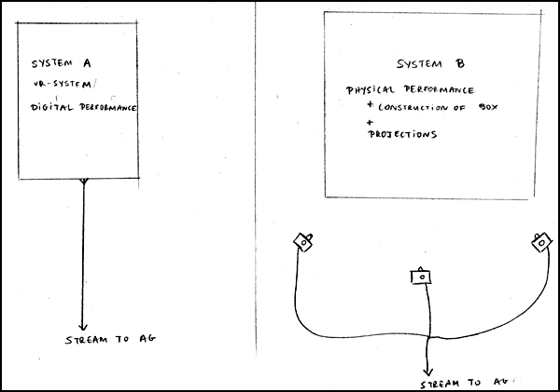
System Plan – Top Level

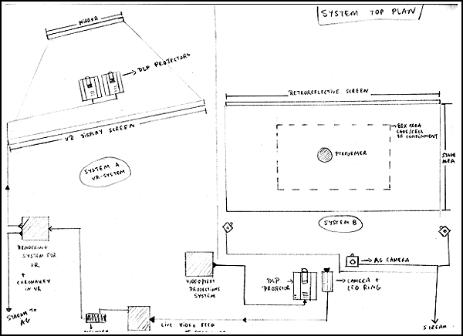
System Plan – Detailed Top View

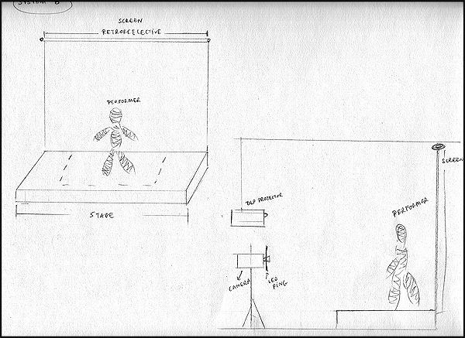
System B – Perspective & Side View

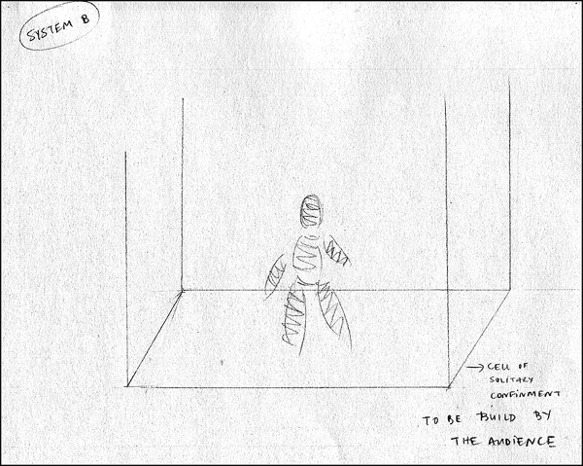
System B – Confinement Cell & Performer

Hardware Specs/Required Components

I. C-Wall System (VR SYSTEM)

  - Hardware
    - Rendering & Processing Computer
    - VR Display System
2 DLP Projectors
Stewart Black Rear Projection Screen ( 6’ * 5’)
A mirror for reflecting Projection Data (3’ * 4’)

  - Software
    - Operating System
Redhat Linux 7.3 for Rendering System
Windows 2000 for video streaming system
    - Graphic Library
SGI OpenGL 1.2
SGI Performer 2.5.2 for linux
    - Virtual Reality software library
VRCO CAVElib 3.1
CAVERNsoft G2 library - developed by Electronic Visualization Lab (EVL), UIC
YGDRASIL 0.11 - developed by Electronic Visualization Lab (EVL), UIC

II. Chromakey System Components

- Live Video Streaming System
    - Live Video streaming Computer (Windows 2000)
    - Camera to stream live video

- Chroma key materials (purchased by EVL, from Play Corp.)
Super Bright Blue LED light Ring & Dimmer control switch (Holoset ring, Swiderski electronics)
Retroreflective Backdrop Screen (dimensions: 8ft width x 9ft height)

III. Physical Performance

A. Hardware
    - DLP Projector
    - Video Projection Computer
    - AG cameras

B. Stage
    - Stage area materials (wood, paint)
    - Confinment cell materials (plexiglass)

