Summary

Repairing customized skull injuries requires customized cranial implants and current visualization research aims to develop a new approach to create these implants. Following pre-surgical design techniques pioneered at the University of Illinois at Chicago (UIC) in 1996, researches have developed a cranial implant creation application incorporating haptic force feedback and augmented reality. The application runs on the Personal Augmented Reality Immersive System (PARIS™), allowing the modeler to clearly see his hands in virtual workspace. A two step process consisting of 3D registration and virtual sculpting has been designed for creating the implant. This research lays the foundation to eventually replace tge traditional modeling and implant generation process.

TABLE OF CONTENTS

Chapter

- INTRODUCTION
  - Background
  - Problem Statement
  - Solution Overview

- CRANIAL IMPLANT DESIGN
  - UIC Cranial Implant Research
    - The Analysis
    - Data Acquisition
    - Implant Creation And Surgical Fitting
  - Haptics And Immersive Modeling – PARIS™
  - Multi-Resolution Modeling And Data Structures
  - Haptic Rendering
  - Sculpting system
  - 3D Registration

- IMPLANT DESIGN: HARDWARE AND SOFTWARE ISSUES
  - Device And Hardware
    - PARIS™
    - PHANToM™
    - Tracker

TABLE OF CONTENTS (Contd..)
Chapter

  - Libraries
  - 3D Registration Tools
    - AIR
    - Analyze

- IMPLANT DESIGN: DESIGN AND IMPLEMENTATION
  - Existing Work
    - Traditional Method
    - Pre-surgical Cranial Implant Design Using The PARIS™ Prototype
  - Implant Modeling: Initial Approaches
    - Cube Stack
    - 3D Grid
    - FEM
    - NURBS
  - 3D Registration and Warping
    - Registration and Warping
    - Volume Deletion
    - Volume Subtraction And Threshold
  - Volume Sculpting
    - Sculpting Tool
    - Addition Tool
    - Recording Tool
    - Features
  - Integration And Pipeline

TABLE OF CONTENTS (Contd..)
Chapter
- RESULTS AND DISCUSSION
  - Results
  - Discussions
  - Other Potential Applications
6. CONCLUSIONS AND FUTURE WORK
6.1 Lessons Learned
6.2 Hardware and Software Issues Faced
6.3 Future Work
7 BIBLIOGRAPHY
8 APEENDICES
APPENDIX A List of Abbreviations
APPENDIX B Building the application

Chapter 1

Introduction

  - Background
Today a prosthetic implant is created by a medical sculptor who has expertise in anatomical modeling. However, even with the aid of automated manufacturing techniques, the design process poses several problems. Techniques developed at the University of Illinois at Chicago (UIC) in 1996 have greatly improved the practice. Virtual reality now aims to augment these tools and methods using a prototype display system.
Closing defects in the cranium offers therapeutic benefits. These benefits include restoring the shape of the head, protecting vital brain tissue, minimizing pain, reducing operating and recovery times and in some cases improving cognitive capabilities. Unfortunately, several factors limit the cranial implant availability. Insurance companies do not cover the highly probative costs of such an operation. As only neurosurgeons and medical sculptors possess the specialized anatomical knowledge, assembling the necessary expertise is difficult and hence travel expenses for both patients and specialists increase the overall cost. Currently acrylic polymer is the most commonly used implant material. When used intra-operatively, the material exudes extreme heat as it solidifies. Exposing the brain to these temperatures can cause tissue damage. For this reason, pre-surgical implant design and fabrication is vital. Traditional cranial implant fabrication and surgical placement methods are heavily dependent on subjective skills and procedures. At times it has been necessary to produce multiple implants of various sizes to provide the surgeon the choice of the best fitting implant during surgery. The cranium’s anatomical complexity impedes reconstruction without extensive planning
The American Association of Neurological Surgeons reported that there were 220,065 cranial procedures performed in 1999 alone [AANS02]. There are approximately 4000 neurological surgeons and 7000 hospitals in the United States. The specialization of neurological surgeons along with the need for medical modelers makes it very difficult to assemble the expertise necessary to repair large cranial defects. Large-scale health emergencies that may include interruption of transportation and other infrastructures will make it even more difficult to gather the expertise and personnel to perform these critical procedures. Even in the best of times and with the best resources, the design, fabrication and implantation of large cranial implants has many problems including poor fit and long operating room times [Dujovny99]. Pre-surgical implant design and fabrication alleviates many of these shortcomings.

  - Problem Statement
The 1996 UIC approach incorporated a series of expensive manual manufacturing steps to produce a custom-fitting implant. These techniques serve as a guide for implementing a digital approach combining augmented reality and haptics. Medical sculptors are trained to use their hands and their abilities are heavily dependent on that fact. The awkward control devices used by traditional VR systems are not conducive to intricate sculpting techniques. Introducing force feedback allows user to feel the virtual defect and implant models, giving the user the sense of touch that is important for 3D modeling [Massie98]. The design process also requires that medical sculptors clearly see their hands while modeling an implant. Using augmented reality we can combine real and virtual information, allowing real time interactivity and managing 3D registration [Azuma97].

  - Solution overview
The major goal of this research work is to develop and deploy a surgical system for tele-immersive consultation, surgical pre-planning, implant design using virtual sculpting, post operative evaluation and education. This data is used to produce physical implants that fit precisely. Collaborators can be anywhere in the networked world viewing and interacting with a stereo 3D model of a patient and implant on a personal computer workstation. The implants will be fabricated by networked stereo lithography and rapid prototyping systems.
The process of implant design begins with CT data of the patient in the Personal Augmented Reality Immersive System (PARIS™) system. In this process the medical modeler creates a virtual implant that precisely fits a defect generated from patient CT data. The prior work in this process provides a prototype to load the CT data in a PARIS™ system and interactively manipulate the same. This research work is aimed at supplementing the prior work to create the actual implant using 3D registration and virtual sculpting techniques. The CT data is passed through a pipeline of 3D registration where the information is added to the defective side of the skull from the other side, by registering the two sides of the skull and subtracting them from each other. The difference volume which contains the implant is then modified by a process of virtual sculpting, volume addition by the medical sculptor.
The sculpting and addition process are done with the help of various tool shapes. In the PARIS™ augmented reality system the user’s hands and the virtual images appear superimposed in the same space and hence the user can feel what he is visualizing. A haptic device supplies the sense of touch by applying forces as a haptic cue for the medical modeler to form the implant.

Chapter 2
RELATED WORK

This chapter describes the background concepts in detail. Previous cranial implant techniques provide the basis for the virtual tools and capabilities. This chapter begins by examining previous implant creation techniques and the production pipeline. The subsequent section deals with haptics in augmented reality followed by an analysis of multi-resolution modeling and data structures. Haptic rendering and interactive sculpting techniques used are explored next. Finally it ends with a brief note on 3D registration methods.
Previous work explores virtual sculpting, hierarchical modeling and haptic rendering, but the challenges of unifying these concepts into an immersive cranial implant design application have not been examined. This research work also uses an approach of using 3D registration as the basis for the virtual and interactive sculpting operation and provides a good platform for using the sculpting algorithm with more precision for medical applications.

2.1 UIC Cranial Implant Research
In 1996 a new semi-automated technique for creating cranial implants was pioneered by Dr. Fady Charbel, Ray Evenhouse, and their team [Dujovney99]. These custom-fitting cranial implants are made prior to surgery using the patient’s CT data, resulting in a near-perfect fit. A computer model of the skull and defect is generated from the CT data. This polygonal data is sent to rapid prototyping stereo lithography machines, where a physical model of the skull with defect is made as shown in figure 2.1. This model serves as a template for the manufacture of the implant. A sculptor shapes, molds, and casts the implant based on the model. Shaping the clay, the sculptor progressively sculpts the implant’s mold, and then casts the implant by filling the mold with a medical-grade polymer. After casting, the implant is sterilized and prepared for surgery.

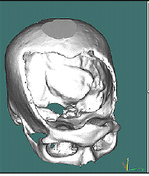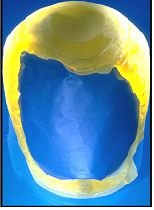
Figure 2.1 The Polygonal model of the skull (left) and a physical model of the defect used as a template (right)
A nine-patient study was conducted using the technique described [Aans99]. In none of the cases was it necessary to alter either the implant or patient’s skull for proper implantation. The use of patient-specific stereo lithographic models permits the manufacture of implants with near perfect fit and complex geometry which intra-operative reconstruction techniques are not able to duplicate.

2.1.1 The Analysis
The cranial implant design process involves three professionals, who work in tandem to create the final implant. The process is initiated by the referring physician. The patient interacts with his personal physician who passes on the data and evaluation to the neurosurgeon. The neurosurgeon then decides how to proceed, collects the patient’s medical data and passes it on to the medical sculptor. The medical sculptor evaluates this information and creates the implant.
2.1.2 Data Acquisition
The patients computed tomography (CT) scans, about one-millimeter thick, are obtained using a General Electric High-speed Advantage scanner. The images are stored in a format based on the Digital Imaging and communications in Medicine (DICOM) protocol. As the digital information of the patient is the basis for the implant creation process, this step is very significant.
Construction of a file for the rapid prototyping machines follows next. This is done by using the pixel data from the CT scanned images and segmenting them. Re-sampled data is used to create an approximate stereo lithography output file for use in rapid prototyping. This re-sampled data now presents the tool path guide for the stereo lithography machine’s model generation process.

2.1.3 Implant creation and surgical fitting
The defect model geometry is imported into a stereo lithography machine, in which as the laser fires into the polymer, its energy converts the polymer into a solid mass. The finished model is removed from the vat, and submitted to the final curing stage for UV radiation. The final model is a precise physical representation of the patient’s skull and defect CT data. This model serves as a physical template for fabricating the final implant. Once the implant is created it is sent to the operating suite for sterilization. Finally depending on the bone defect location, the surgeon positions the patient in the appropriate position. The implant is fixed in place with a minimum of three titanium plates and screws. The surgeon then seals the incisions and closes the skin.

2.2 Haptics and immersive modeling – PARIS™
Repairing severe human skull injuries requires customized cranial implants, and current visualization research aims to develop a new approach to create these implants. Following pre-surgical design techniques pioneered at the University of Illinois at Chicago (UIC) in 1996, researchers have developed an immersive cranial implant application incorporating haptic force feedback and augmented reality [scharver 04a, scharver 04b]. The application runs on the Personal Augmented Reality Immersive System (PARIS™) [johnson00], allowing the modeler to see clearly both his/her hands and the virtual workspace. The PARIS system also attempts to addresses the drawback of having a limited workspace, mentioned in a survey on issues in haptic environments by Burdea. [burdea00].
The strengths of multiple software libraries are maximized to simplify the development of this system. This system has been developed using the CAVE Library (CAVELib), TGS Open Inventor[tgsinventor], Kitware's Visualization Toolkit (VTK)[VTK03], and SensAble Technologies' General Haptics Open Software Toolkit (GHOST™)[Senable01]. CAVELib is used to handle the model and view transformations for head tracked stereo rendering. The Open Inventor data format is used for representing polygonal data because it’s human-readable and supported by many 3D modeling packages and TGS Open Inventor is used for loading the Inventor data. A collection of visualization algorithms from VTK has been used to store raw data and construct visual representations of that data. Finally, GHOST™ is used to perform the haptic rendering by interfacing with the PHANToM™ desktop device.
The modeler converts the patient's skull CT data into polygon geometry. The application loads the model and after adjusting positions as needed, the modeler may manipulate the skull data to obtain the best view of the defect. A pencil tool creates 3D annotations and highlights the edge of the defect. This defect outline serves as input for calculating a defect model separate from the entire skull. Viewing the defect, the sculptor makes annotations indicating where to attach bolts during the surgery. Feeling the surface of the defect allows the modeler to determine how to sculpt the patient's implant. Referring to the digitized photographs, the sculptor adds material into the hole, slowly shaping the implant. When the work is completed, the application saves the model file to disk for evaluation and eventual fabrication

2.3 Multi-resolution modeling and data structures
Multi-resolution modeling maintains objects at different levels of detail, where the levels of detail may be different in distinct areas of the object. Intelligent use of data structures and traversal methods can make a significant difference in algorithm performance. In particular, the use of hierarchical data structures to summarize volume information can prevent useless traversal of regions of little interest. However, the storage and traversal of hierarchical data structures themselves can add to the resource consumption of the algorithm, both in terms of time and space.
A hierarchical framework approximates volume data with different levels-of-detail. The framework is generated through a recursive subdivision of the volume data and is represented by binary trees. An error based structure is generated by recursively fusing a sequence of nodes from different levels of the framework and this significantly reduces the number of voxels required to model an object, while preserving the original topology. Zhou et al [Zhou97], Marchesin et al [Marchesin04] and Rottegger et al [Rottegger 03] used a hierarchical tetrahedral framework in which the initial cube is split into twelve tetrahedrons and from then on each tetrahedron is split, into two along the largest side, based on the availability of data. Octree data structures are the other commonly used form of hierarchical representation of data. The use of octrees for controlling volume traversal is appropriate when regions are regular hexahedra (cubes, rectangular parallelepipeds), as is common in medical imaging. Using an octree for the representation of 3D object is not new a idea. Wilhems and Van Gelder’s [Wilhems00], Frisken et al [Frisken00] (Adaptively Sampled Distance Fields) and Hasup Lee et al [Lee02], have used the octrees based hierarchical approach. While they provide spatial and temporal efficiency for large data sets, their models are not suited for volume sculpting with discontinuities among different levels.
The octree approach has been used in this research work, over the other data structures for the representation of volume data. Apart from using hierarchical data structures, they are more suited for medical data as they have sparse volumes and branching is done only when a data is found in the sub-tree. Also the volume buffer lends itself to boolean operations that can be performed on a voxel-by-voxel basis during the voxelization stage. This property is very advantageous when constructive solid geometry (CSG) is the modeling paradigm and hence more useful in this work. CSG operations such as subtraction, union, and intersection between two voxelized objects are accomplished at the voxel level [Meagher82].This reduces the original problem to one of evaluating a CSG tree of such operations. This is not so intuitive in case of a tetrahedral framework. Also future work making use of tools with different shapes can be easily integrated with the use of an octree.
Traversal times on machines with relatively small memories can be highly dependent on traversal order. Assume the x dimension varies fastest in the array that stores the data volume, followed by y, and then z. Traversing the volume in the order z-y-x could take many times as long as an x-y-z traversal, due to the time taken by page faults. In such cases, storing the data in octree order to equalize traversal costs might be preferred.
In this research work, the octree based approach not only allows space saving representations but also provides a framework for boolean operation on volume which is vital in CSG operations.

2.4 Haptic Rendering
Just as in computer graphics, the representation of 3D objects can be either surface-based or volume-based for the purposes of computer haptics. While the surface models are based on parametric or polygonal representations, volumetric models are made of voxels. The existing techniques for haptic rendering with force display can be distinguished based on the way the probing object is modeled:
(1) point-based, where the probe is modeled as a point (this model is analogous to exploring and manipulating real objects with only the tip of a stick),
(2) ray-based, where the probe is modeled as a line segment or
(3) a 3D-object, where the probe is made up of a group of points, line segments and polygons. The type of interaction method used in simulations depends on the needs and complexity of the application. Today, many algorithms exist to render the shape, surface texture, softness, and dynamics of virtual objects.
In recent years, many researchers including Freeform [Sensable99], Lin et al[Lin00] and Johnson et al [Johnson98] have computed point-object contacts to render force (3-DOF). The approach in most of the point based cases is, to subdivide the object and associate each sub-volume with a surface and to determine the feedback force directly from penetration. This works well for simple geometric shapes, but for complex shapes this significantly increases the force computations. Zilles et al. [Zilles95] first proposed a framework to model contact constraints. Ruspini et al have [Ruspini97] also presented a high-level haptic interface library and a virtual proxy framework. Avila et al [avila96] have simulated virtual tools by applying three-dimensional filters to some properties of the data within the extent of the tool and also used an accelerated ray casting method. The proxy object method gives an unambiguous force vector. Problems occur when touching the concave portions of an object, as multiple surfaces can be active. Also if the proxy point is pushed halfway through an object, it will be pulled through the rest of the way.
A point based system has been used in my work but the complex computations have been avoided by leaving the force-feedback to GHOST™, a haptics toolkit from SensAble Technologies. Objects are continually added to the scene and GHOST™ provides feedback and generates a callback to handle the collision state. This also allows flexibility in adding only objects that provide forces to the scene, thereby avoiding the multiple contact surfaces and the proxy point popping problems.
One of the major issues with using GHOST is the servo loop error, due to having large number of objects in scene. In this graphics and haptics are separated, so they are independent of each other. The scene graphs are similar in both haptics and graphics and the transformations are updated via callbacks.

2.5 Sculpting System
In order to design 3D digital models more easily and intuitively, many researchers have proposed methods to sculpt 3D digital models in virtual environments. Implicit surface approaches and volumetric approaches are the two main categories. Implicit surface approaches [chai98, bloomenthal99, Wong00, Li01] use Non-Uniform Rational B-Splines (NURBS) to represent the isosurface. Input device such as a data glove or force feedback device are used to manipulate the control points. The main disadvantage of implicit approaches is that it is difficult for users to create the exact shape exactly they want by manipulating control points. Furthermore, it is also a challenge for implicit surfaces to form complex shapes. For instance, two NURBS have to be patched together to form a sharp feature.
Other researchers adopt volumetric approaches. Voxel–based sculpting was introduced by Galyean and Hughes [Galyelan91] as a new method of creating free form 3D shapes by interactively editing a model represented in a voxel raster. Kaufman and Wang [Wang95] have created another sculpting system where the tools are based on the notions of carving and sawing. The approach of Kaufman and Wang is more suited for the creation of art shapes and the algorithm of Gaylean and Hughes is more suitable for creating organic shapes i.e the shapes naturally occurring in the world. Ayasse et al [ayasse01] have created a sculpting system that handles tools of any shape but the work approximates the shapes to achieve interactive rates.
Other previous works such as that by, Baerentzen [Baerentzen 99], Ferley et al [Ferley99, Ferley00], [Galyean91] and [Wang95] used a sampled scalar-field to represent models. This kind of object representation produces a smoothing effect for features. Multi-resolution volumetric sculpting [Ferley 02] adopted an adaptive resolution scheme based on the local detail of an engraving tool to represent the sculpting data. Nevertheless, sculptures created by this system still reveal rounded corners and smoothed edges. Perry et al. [Perry01] proposed a sculpting system with adaptively sampled distance fields (ADFs) [Frisken00, bremer01] to preserve sharp feature with an efficient refinement, but the system was limited to local modification
Another related work from Jagnow and Dorsey [Jagnow02] used displacement maps to modify the solids. The method was unfortunately suited only for minor modifications in a volume and is not suited for major changes in shape or even drilling a hole in the solid. Recently, SensAble Technology developed a haptic modeling system, the Freeform™ Modeling System [Sensable99], to create 3D models with a volumetric approach. This system suffers from common volume rendering artifacts and is not suited for medical application in its present state. Also these tools are closed to custom development and researchers cannot add targeted features supporting tele-immersion to the existing software.
The different modalities of the tools found in the previous projects have motivated this research work where the first aim is to create tools that allow the user to work in an augmented reality environment for implant design. The second aim concerns the data structure used to contain the 3D grid model. The memory requirements of a realistically sized 3D grid are not prohibitive for a modern workstation as a volume data usually contains large homogeneously empty regions and a sparse representation would certainly be advantageous. In this research I have used an octree based volume sculpting, and further save the memory usage in representing volumes for sculpting.

2.6 3D Registration
In practice, sets of data acquired by sampling the same scene or object at different times, or from different perspectives, will be in different coordinate systems. Registration is the process of transforming the different sets of data into one coordinate system. Registration is necessary in order to be able to compare or integrate the data obtained from different measurements. In medical imaging (e.g. for data of the same patient taken at different points in time) registration often additionally involves elastic (or non-rigid) registration to cope with elastic deformations of the body parts imaged.
3D registration algorithms fall within two realms of classification: area based methods and feature based methods. The original volume is often referred to as the reference volume and the volume to be mapped onto the reference volume is referred to as the target volume. For area based volume registration methods, the algorithm looks at the structure of the volume via correlation metrics, fourier properties and other means of structural analysis. However, most feature based methods, instead of looking at the overall structure of volumes, fine tune its mapping to the correlation of volume features: voxels, lines, curves, voxel intersections, boundaries, etc.
3D registration is used for registering the left and right halves of the skull volume in this research. I have used feature based methods as there is very little shift in the positions of the voxels, as they are two sides of the same skull, and hence co-relation methods are less suitable for this case. Automated image registration developed by the UCLA (University of California at Los Angles) and Analyze 6.0, a software package developed by Analyze Direct Inc, have been used for this purpose and they yielded desirable results.
This chapter dealt with the previous work related to this research work. It analyzed the existing implant creation technique and then existing versions of haptics in augmented reality environment. This was followed by a section on multi-resolution modeling and then a study of various haptic rendering and interactive sculpting techniques. The final section dealt with the major techniques of 3D Registration. The next chapter deals with the hardware and software issues faced in the research.

Chapter 3
IMPLANT DESIGN: HARDWARE AND SOFTWARE ISSUES

The solution to the problem of implant modeling is to make use of virtual reality so that the medical sculptor can create digital implants efficiently and accurately. This chapter deals with the hardware and software issues in the process of creating the implant. An analysis of the hardware employed, the design of the software, the libraries, APIs used and the reason for these choices are dealt with in this chapter.
The next section deals with the virtual environment, the PARIS™, and PHANToM™ models. The following section analyses the various libraries and APIs used. The last section lists a few 3D registration libraries available and the data flow through the whole process.

3.1 Devices and Hardware

An Augmented Reality (AR) application can enhance a user’s perception by fusing computer-generated virtual information into his view of the real world [Azuma97]. It employs medical images as a foundation to create innovative methods of reviewing, analyzing and modifying the data. From the traditional definition of virtual reality that uses head tracking devices, stereo glasses, and fully immersive environments for interaction with the data to emerging techniques that combine key elements of the animation process with medical images from all three-dimensional modalities, virtual reality provides valuable information for medical education, clinical practice, and research. VR was seen as an obvious solution right from the research done on cranial implants in 1996 [Bibb02, Taha01].

3.1.1 PARIS™

The CAVE [Cruzneira93] was designed in EVL in 1992, and then, a second-generation device, the Immersadesk, was designed in 1995. These systems support 3D vision well, managing separate stereo images for each eye and tracking head motion. There remain two important depth perception cues, occlusion and accommodation, that are not supported correctly in these displays. A nearby object should be visible in front of the user’s hand and the half-silvered mirror in the PARIS™ (Personal Augmented Reality Immersive System) display superimposes the computer generated image over the user’s hands so one does not occlude the other. The second depth cue, accommodation, refers to muscles controlling the eye to adjust sharpness. In a conventional VR display the eye will always focus on the display screen, which is typically significantly farther than arm's reach. The PARIS™ display is designed so that the user focuses on the location where his/her hands are located. This is shown in figure 3.1. The PARIS™ also provides place for the haptic device – the PHANToM™.
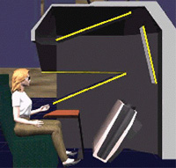
Figure 3.1 Personal Augmented Reality Immersive System (PARIS™)
Using The PARIS™, [Johnson00] a projection-based “augmented” virtual reality display developed at the University of Illinois at Chicago (UIC) Electronic Visualization Laboratory (EVL), a surgeon and medical modeler can view a three-dimensional model of a patient’s computed tomography (CT) data, and collaboratively review, sculpt and “virtually” build an implant using their hands.
The PARIS™ is also optimized to allow users to interact with the environment using a variety of tactile input devices. The PARIS™ uses LCD shutter glasses for stereo visualization and to this is attached a sensor to keep track of the head position of the user. This tracking is performed by a tracker system described in the section 3.1.3. An authentic sensation of the implant sculpting process is achieved using SensAble Technologies’ PHANTOM™ force-feedback device [Salisbury97]. The PARIS™ display has excellent contrast and variable lighting that allows a user’s hands to be seen immersed in the imagery. Sitting at PARIS™ as shown in Figure 3.2, the modeler interacts with the system in a manner similar to the methods pioneered at UIC in 1996. Another important feature is the large workspace that allow the PARIS™ allows the user to have access to important patient data that can be loaded into the scene as well and viewed by the sculptor. In short the PARIS™ system creates a desktop like environment for the doctors.

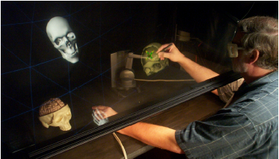
Figure 3.2 A medical modeler "touches" a cranial defect while sitting at PARIS™. The stylus corresponds to a tool held in the right hand; a virtual hand tracks the position of the left hand. A real model remains visible on the table

3.1.2 The PHANToM™
The PHANToM™ was a very good choice for the use of force feedback devices. Just as the monitor enables users to see computer-generated images, and audio speakers allow users to hear synthesized sounds, the PHANTOM devices make it possible for users to touch and manipulate virtual objects. The PHANToM™ (Salisbury and Srinivasan, 1997) is a commercially available force-feedback robot available from SensAble Technologies.
Figure 3.3 shows the two popular models of the four models of the PHANToM available for research. The Desktop model is on the left and the premium model is on the right.
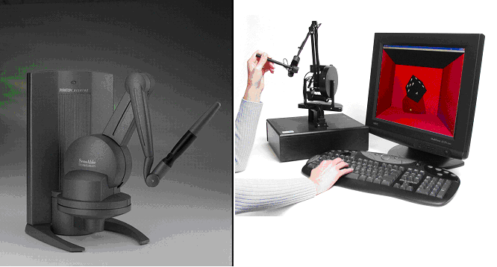
Figure 3.3 SensAble’s PHANToM Desktop(left) and Premium model(right) (image courtesy SensAble Technologies)

The desktop model provides six degree-of-freedom positional sensing and hand movement is done pivoting at wrist. The premium model on the other hand includes a passive stylus and thimble gimbal and provides 3 degrees of freedom positional sensing and 3 degrees of freedom force feedback. The premium model provides more workspace and also is more sensitive compared to the desktop model. The implant creation tool is designed to work in both these PHANToM™ models.

3.1.3 Tracker
Tracking is an important part of any AR device and the PARIS™ uses the PCBird tracking system. The tracking system may be run on a separate computer or it could run in the same computer running the application. The software consists of a trackd server and client, which is a part of the CAVELib Library from VRCO/EVL. The tracker system has two sensors one of which tracks the position and orientation of the users head while the other tracks for the position and orientation of the hand held controller. The controller has three buttons, which are used by the application to handle user events.

3.2 Libraries
The software architecture directs information between multiple libraries [scharver04a] as shown in figure 3.4. The application receives tracking data from the controller in a read-only manner. Interaction with the PHANToM™ requires tighter integration. It is also important to mediate between the different data formats used by the rendering and haptic libraries.
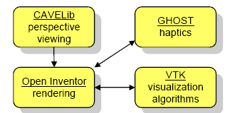

Figure 3.4 Interaction among the various libraries used

Leveraging the use of existing libraries allows development to focus on the environment rather than low-level implementation details. This system has been developed using the CAVE Library (CAVELib), Coin 3D, Kitware's Visualization Toolkit (VTK), and SensAble Technologies' General Haptics Open Software Toolkit (GHOST). CAVELib handles the model and view transformations for head tracked stereo rendering. It generates display threads that synchronize active stereo rendering. Open Inventor is an OpenGL scene graph library optimized for interaction and easy extensibility. Coin 3D is built upon SGI Open Inventor 2.1, enhancing that version's capabilities with multi-threading and immersive interactivity. The Open Inventor model format is human-readable and supported by many 3D modeling packages. VTK provides a comprehensive collection of visualization algorithms to store raw data and construct visual representations of that data. Finally, GHOST provides the haptic rendering by interfacing with the PHANToM™ Desktop device. It spawns a haptic servo thread for handling force feedback processing. GHOST has its own scene graph differing from Open Inventor and VTK, but with similar concepts

3.3 3D Registration tools
Since information gained from images acquired from the left and right halves of the skull is usually of a complementary nature, proper integration of useful data obtained from the separate images is often desired. A first step in this integration process is to bring the modalities involved into spatial alignment, a procedure referred to as registration. After registration, a fusion step is required for the integrated display of the data involved. The choice of registration tool was an important step in the implant production pipeline.

3.3.1 AIR
The Automated Image Registration (AIR) package, developed by UCLA (University of California at Los Angles) is primarily designed to solve several different registration problems that arise in tomography data sets such as the registration of a PET or MRI data set with another, or registration of the data sets of two different subjects. Once the registration parameters are known, the AIR package allows the data to be resampled to generate a final image using any of the following interpolation models:
- nearest neighbor
- trilinear
- windowed sinc
- mixed linear/windowed sinc
- unwindowed sinc
- chirp-z
- mixed linear/chirp-z
Hence this was a good choice for the 3D registration tool and the open source nature of the package allowed easy integration with the existing work. This API was used to perform 3D registration of the two halves of the skull volume data so that the defect can be isolated and used in the generation of an initial implant.

3.3.2 Analyze 6.0
Analyze 6.0 is a software package, developed by Analyze Direct Inc, for multi-dimensional display, processing, and measurement of multi-modality biomedical images. Figure 3.5 shows Analyze used for image processing.
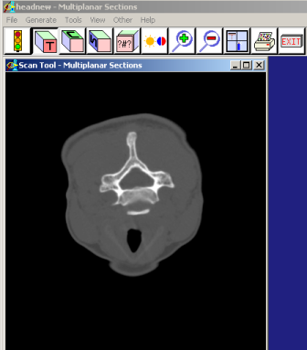
Figure 3.5 Analyze 6.0 being used for 3D Registration
Several features implemented in the 3-D volume-to-volume normalized mutual information registration capability in Analyze provide a more stable basis for the resampling of the match volume during the registration process. The fundamental search algorithm for normalized mutual information performs searches the scale dimensions of the volume, implementing a full nine-degree of freedom registration algorithm. The results produced by Analyze were compared with the ones obtained by using AIR.
In this chapter the hardware and software issues in the process of implant design were dealt with and choices of hardware and software were made. The PARIS™ is used as the augmented reality environment in this research work and the PHANToM™ desktop and premium models provide the sensation of touch. CAVELib library handles the windowing and the tracking systems. Coin3d is used for constructing an interactive visual scene graph and GHOST™ is used for constructing a corresponding haptic scene graph. AIR and Analyze 6.0 are used for 3D registration process for the construction of the initial implant. The next chapter deals with the design and implementation of this work.

Chapter 4
IMPLANT DESIGN: DESIGN AND IMPLEMENTATION
Today a medical sculptor utilizes anatomical modeling expertise to sculpt a prosthetic implant. However even with the aid of automated manufacturing techniques, the design process poses several problems. Techniques developed at the University of Illinois at Chicago (UIC) in 1996 have greatly improved the practice. Virtual reality research now aims to augment these tools and methods using a prototype display system. This chapter deals with the design and implementation aspects of the implant design.
The next section discusses existing work in this process- the traditional method followed in 1996 at UIC and tele-immersive modeling using PARIS™ prototype. Section 4.2 describes the general method adopted and some approaches which were not followed. Section 4.3 details the pipeline of 3D registration and the method of obtaining the initial implant. The following section deals with volume sculpting and addition algorithms and also some of the features added. The final section shows the whole pipeline of implant generation. The cranium’s anatomical complexity impedes reconstruction without extensive planning. Pre-surgical cranial implant design and fabrication using this method alleviates many of these shortcomings.

4. 1 Existing work
4.1.1 The traditional method
Dr. Fady Charbel, Ray Evenhouse, and their team at UIC pioneered a pre-surgical cranial implant design technique in 1996 [Dujovney99]. The process produces custom-fitting cranial implants prior to surgery using the patient's computed tomography (CT) data. The medical modeler loads the patient's CT data into medical computer-aided design (CAD) software and produces a digital model of the defect area. This polygonal model is exported to a rapid prototyping stereo lithography machine. This computer-aided manufacturing (CAM) process fabricates a physical defect model. The medical modeler sculpts, molds, and casts the implant based on this model. Shaping the clay on the defect model, the modeler progressively sculpts the form of the implant's mold. The modeler then casts the implant by filling the mold with a medical-grade polymer. After casting, the implant is sterilized and prepared for surgery. To date, nine patients have received implants using this method [AANS99].

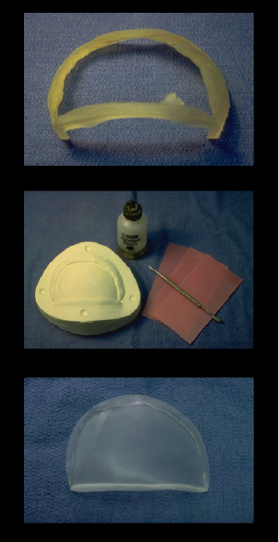
Figure 4.1- The UIC pre-surgical implant process generates a defect model from the patient’s CT data (top). This model serves as the basis for sculpting the implant with clay and wax(middle). The final implant is cast using a polymer resin (bottom).

4.1.2 Pre-surgical Cranial Implant Design using the PARIS™ Prototype
Following pre-surgical design techniques pioneered at the University of Illinois at Chicago (UIC) in 1996, researchers have developed an immersive cranial implant application incorporating haptic force feedback and augmented reality. The application runs on the Personal Augmented Reality Immersive System (PARIS™), allowing the modeler to see clearly both his/her hands and the virtual workspace. The strengths of multiple software libraries are maximized to simplify development
This approach started out with the process of data acquisition, which is the generation of one-millimeter thick slices, by tomography scans. These images are archived on optical disk using the Digital Imaging and Communications in Medicine (DICOM) protocol and also sent through the university's data network to a graphics workstation. Data can then be stored for later processing or imported directly into modeling software such as Mimics developed by Materialize.
Raw Volume Data
Polygonal Model
Coin3D
GHOST
PARIS™
and
PHANToM™
Patient
Marching Cubes
CAT Scan

Figure 4.2 Data acquisition pipeline. The patient’s 3D scan produces a CT data, which is converted into a polygonal model and loaded into the Coin3D and GHOST scene graphs and interacted with the PHANToM™ at the PARIS.™

As shown in figure 4.2, raw volume data is converted into a polygonal model using algorithms such as the Marching cubes[Lorenson87] and added to the scene graphs of Coin3D[coin3d] and GHOST.

4.1.2.1 Load data

The skull model used was the visible human male skull model taken from the “visible human project” of the National Library of Medicine [Akermann95]. This was done to preserve the confidentiality of patient data and use a publicly available model for the purpose of research. A defect was artificially added to the skull model as shown in figure 4.3. The CT Data was used for the construction of polygonal models and loaded into the PARIS™. This step was needed as the PHANToM™ provides force feedback to only the primitives it has, and doesn’t handle volume data interaction and force feedback.

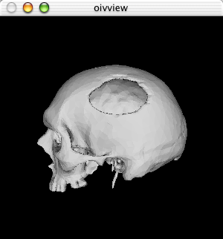

Figure 4.3 The Visible Human Male Skull model with an artificial defect created

4.1.2.2 The Manipulators

The scene in PARIS™ is used to simulate the physicians desktop and the patient’s data is loaded as 2D images in the VR workspace so that the sculptor can use them for reference. Transformation tools were provided based on GHOST manipulators to transform the skull. GHOST provides three types of manipulators: translation, rotation and scaling.

4.1.2.3 Defect generation

Generating defect from the skull model was the next step and this was done by tracing points using the PHANToM™ along the defect area. These points are then converted to lines and the geometry is clipped using algorithms from VTK to generate the defect area.

4.1.2.4 Implant generation

The output of the above defect isolation process is as shown in figure 4.4. The procedure is explained in detail in [scharver04a]

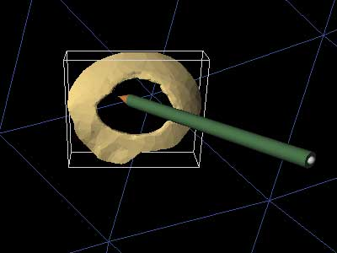
Figure 4.4 The generated defect with the bounding box

The virtual sculpting method takes over from this step with methods to fill in the defective area of the isolated skull defect.

4.2 Implant Modeling: Initial Approaches

The process of volume sculpting is used to create a correct implant for the defect. One main issue to be addressed is that not only does the implant have to have the right shape to fit in the defect, but it also must have the right curvature to look good. The solution adopted was a two-step process. The first step was a 3D registration process for getting an initial implant with a good curvature. The sculpting process starts with this initial implant, and then employs tools to alter its geometry and make it fit the defect. The process is similar to the idea of chiseling out a block of stone to form a statue. Prior to this method, different approaches to model the implant were investigated and this section introduces those approaches while analyzing the reason for not making use of those methods.

4.2.1 Cube stack
The first approach towards volume sculpting was to just consider a stack of cubes of similar sizes and to remove each unit cube when the PHANToM™ came in contact with this. There were practical difficulties in the approach as the location of PHANToM’s stylus in space needed to be calculated at a frequency of 900 Hz, and at this high frequency the number of collidable object the scene graph can have is limited to a few thousands, and this limits the number of cubes that can be considered. Hence using a cube stack to form a solid cube was not researched into based on the performance considerations.
4.2.2 3D Grid
The next approach was to use a 3D grid model, which is the reverse of the cube stack approach with the 3D space used instead of a solid cube. The whole workspace of the PHANToM’s is subdivided into a 3D grid and as the PHANToM™ moves around, the grid is populated and the construction of the implant is done. This approach for the construction of the implants was not fruitful because this made aliasing more and more evident, and made the implant rough. Sometimes it even caused the implant to be an irregular and discontinuous solid.

4.2.3 Finite Element Method
The FEM model is based on splitting the solid into smaller elements and measuring the force over numerous elements of smaller magnitude and then summing up all the forces over the whole area [Keeve96]. The approach can be summed up as follows
- Obtain the points traced from the PHANToM™ stylus.
- Construct a solid from the points traced using the vtkDelaunay filter and also a solid FEM from the points. The material properties must be a clay model so that it can allow deformations.
- The FEM consists of a table of data and when any point is displaced by ‘x’, the force provided is given by the equation F=k.x.
- After each displacement action, a new set of points are formed and the corresponding new table is calculated
The four steps need to be continuously repeated. The FEM was a very precise and feasible method for the modification of implants but it is very slow to be performed at run time. If the model is changing its shape very often, then FEM is a very slow method. So due to speed consideration and complexity, this model was not researched further.
4.2.4 NURBS
NURBS are industry standard tools for the representation and design of geometry [chai98, bloomenthal99, Wong00, Li01]. Some reasons for the use of NURBS are,
- They offer one common mathematical form for standard analytical shapes (e.g. conics) and free form shapes.
- They provide the flexibility to design a large variety of shapes
- They can be evaluated reasonably fast by numerically stable and accurate algorithms
Interacting with the NURBS surface haptically had its share of difficulties. GHOST did not have a NURBS node and modeling with the huge number of polygons created by the NURBS caused the PHANToM™ to crash in the servo loop. A good method to overcome this was to use callbacks. Touch sensation is required for haptic NURBS modeling and hence a sphere was added to each of the control points of the NURBS as shown in figure 4.5. Touching the spheres with the PHANToM™ provides the necessary callback to the GHOST, which calls the SoNurbsSurface node in the Inventor scene graph. This visually changes what the viewer sees on the screen. This approach was not responsive when the number of callbacks was large. This typically happens in the process of creating the implant due to the large number of adjoining surfaces.
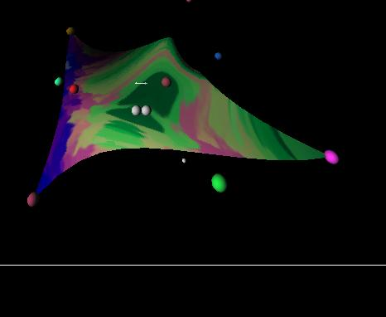
Figure 4.5 Haptic NURBS modeling with the touchable spheres acting as control points for the curve

The above four approaches exposed the practical difficulties in modeling an implant. The FEM based model was the closest to a good solution, but was suitable only for minor modifications to the object. The process of implant design involves more active modification of the implant. Another important problem was the curvature of the skull, and none of the above approaches address the issue of how to get the correct model of the implant. The solution was to use a method of 3D registration before performing volume sculpting. This generates an initial approximate implant that has a good curvature and only fine changes are needed in improving the curvature. The next section deals with the process of 3D registration.

4.3 3D Registration and warping

The symmetry between the 2 sides of the skull has very good information for building an implant. Figure 4.6a and figure 4.6b depict the process of image warping and 3D registration.
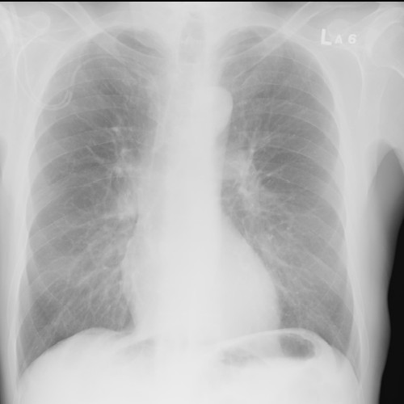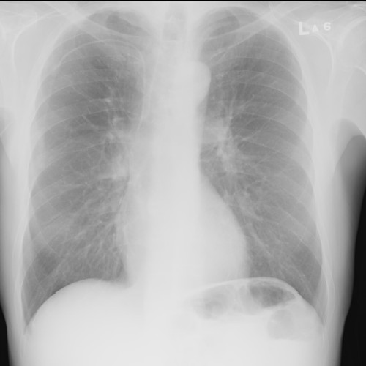

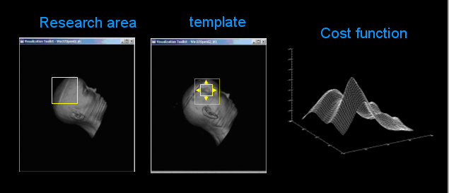
Figure 4.6a The procedure of image warping (top); 4.6b The region of interest being warped based on the template skull and the corresponding registration cost function (bottom)
In this case the implants are constructed in the following manner.
- Split the skull into 2 parts the left and the right part. Let’s assume the right part has the defect. The left part of the skull is mirrored to get a volume, say left_m
- Register the left_m part of the skull with the right part. Registration involves moving the left_m part around so that it matches the right part and then using the transformations for each and every region of interest in the left part.
- Warp the output of the second step with respect to the right part. Let’s call it left_wr.Now the shape of the left warped and right volumes is very much the same except that the left has no defect and the right has.
- Subtract the two volumes to get a volume with the initial implant, and also some noise.
- Eliminate the noise and artifacts from the subtracted volume to get the correct implant volume.
- Feed the output from step 6 to the sculpting algorithm for finer refinement.
For the purposes of registration, software called Automated Image Registration (AIR) and Analyze 6.0 was put to use.

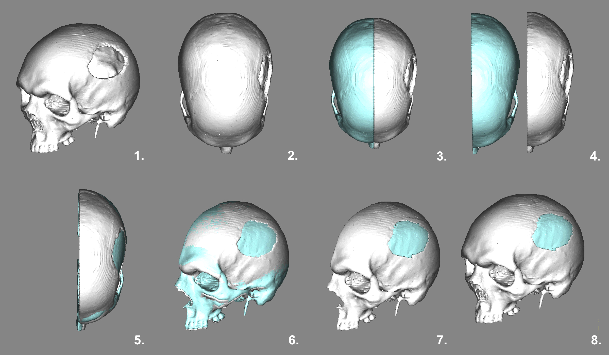

Fig 4.7 is a three-dimensional reconstruction of a human skull derived from CT scan data [1]. The skull has a large defect in the left parietal area. The skull from [1] seen from a top view [2]. The skull has been divided along its axis of symmetry (mid-sagittal plane) [3]. The right (normal) half of the skull has been reflected across the axis of symmetry [4] Using image registration algorithms, the normal skull half is registered with the defect half of the skull [5]. The registration process shown from a different (3/4) view. Note that the defect is being partially filled by the normal volume of the reflected right skull half [6] The reflected half skull and the defect skull are subtracted. The difference between the two volumes represents a preliminary version of the implant [7]. A view of the complete skull with roughly restored contour. Additional modeling tools are used to refine the implant shape and prepare it for fabrication [8].

Registration and Warping

The twin steps involve finding the transformations for one volume to match another. The two volumes are the mirror volume of one half of the skull, say left, and the other defective half, say right. The two volumes are registered using one of the two methods of registration described: AIR and Analyze. The output of the above process is a registered volume of left half of the skull with respect to the right half.

Volume deletion

This step involves the deletion of small bony surfaces within the defective area of the skull prior to the subtraction process. This is done to get an implant that fills in the whole defect area. As shown in figure 4.7, if the correct implant was to be developed for the defect in figure 4.8 left, only the missing areas inside the circle would be automatically generated and this would not be a viable implant. To avoid this problem the defect area is cleared to create a hole (figure 4.8 right) so that the correctly shaped implant can be generated.

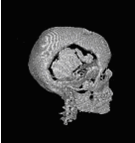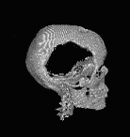
Deletion

Figure 4.8 (Left) Right half of skull and (right) right half with defect area cleared

This is done by using the PHANToM™ and selecting a bounding volume on the polygonal skull. This is then mapped to the volumetric skull and deleted.

4.3.3 Volume subtraction and threshold

The next step involves the volume subtraction of the defective volume from the warped volume. The output of this step contains the difference volume, which has the implant and also other differences and artifacts. It also contains all parts of the skull including the bone and the flesh. The next step is to threshold the values of the volume so that only the bony areas are available and other parts are not included. This is done by checking the scalar value of intensity and allowing only the ones greater than say 150 (on a scale of 0-255).

The output of the process of 3D Registration is an initial implant that has good curvature and also an approximate shape. This is then modified to fit in the defect area by the process of volume sculpting. This method is explained in the next section.

4.4 Volume Sculpting
Interactive modeling of 3D shapes on a computer should be as simple and intuitive as manipulating a clay model. Present systems for modeling (or sculpting) 3D objects are based on shape representations which impose undesirable constraints on both the user interface and on the range of shapes that are possible. The sculpting system described here is based on an octree based multi-resolution representation rather than the traditional surface oriented representations. Volumetric representation and volume visualization are normally associated with medical data and visualization but the volumetric representation is also very well suited to solid modeling.
The user sculpts by moving a 3D locator, the PHANToM™ inside the model. Every time the locator moves, voxels are added or subtracted in the grid. A free-form interactive modeling technique based on the concept of sculpting a voxel-based solid material, such as a block of stone or wood, has been developed using 3D voxel-based tools. The sculpting system supports operations such as removal and addition. Finally, two technologies have proven to be very effective in the context of volume graphics: constructive solid geometry (CSG) and level set techniques. CSG is a paradigm that has been used for many years in the context of solid modeling. Intuitively, CSG is about adding and subtracting shapes from other shapes[Gain96 Hirato95 Wang95]. For instance the user may add or subtract a sphere from the solid he is working on. CSG is easily implemented in the context of volume graphics. Level set techniques are used for modeling level set models, which are a new type of geometric model for creating complex, closed objects. They combine a low-level volumetric representation, the mathematics of deformable implicit surfaces, and powerful, robust numerical techniques to produce a novel approach to shape design [Bloomenthal01]. Level set techniques are most suited for regular geometry and not suited for implant design.
A typical medical volume data, after thresholding, contains large homogeneously empty regions, and by not representing these regions, it is possible to reduce the memory requirements substantially. A traditional pointer based octree data structure has been chosen to represent the volume. An octree may not always be more compact than an array, but is more efficiently represented in an octree than in an array. The volume is recursively subdivided until either the subdivided volume is empty, or the subdivision has reached the leaf level. In the first case the subdivided volume is an empty leaf node that is represented by a NULL pointer. If the leaf level has been reached a voxel is inserted. Hence, for volumes of size 256*256*256, the leaf level is eight.
The technique employed is similar to the one used by [Levoy 88.] but the classification is binary, i.e. voxels with densities greater than the isovalue are wholly opaque. The octree data structure has proved to be a very efficient and flexible way of storing the volume, and it has one more important advantage. By allowing voxels to be inserted at different levels in the octree, one can obtain a sparsely represented voxel raster with dynamic resolution.

4.4.1 Sculpting tool
The initial data structure for multi-resolution volume sculpting is quite simple except that there is no leaf level since leaf nodes may be inserted at any level. This has two important implications: Non–empty homogenous regions may be grouped together and represented by a voxel at a lower level of subdivision, thereby storing the volume more efficiently. Fine details may be added at a high level of subdivision. This is especially important, since it enables us to have high resolution only where it is needed i.e when the user chooses a tool, he not only chooses the and size, but also the level of subdivision where voxels are to be inserted into the octree

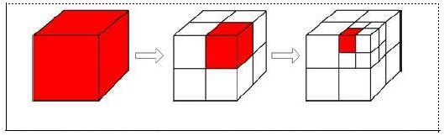

Fig 4.9 Illustration of an octree based subdivision scheme and a hierarchical fitting structure, where the shaded color denotes the node that is to be sub-divided

Initially a cube of size 256 or 128 is used. Based on the position of the PHANToM™ the cube is subdivided into eight more cubes, each 1/8th the size of the original cube as shown in the figure 4.9. Then one of the eight sub cubes is chosen based on the phantom position and the same algorithm is applied again. The size of the cube removed at the highest resolution, the minimum size cube removed is based on the size of the tool. If a tool of size 4 mm is used, then the cubes are sub divided until the sub-divided cubes reach 4mm. After that no further splitting occurs. The user is provided some guidelines for the sculpting tool by showing the defect as a haptic cue. The user can feel the defect and then sculpt the crude structure based on that. The approximate implant of the 3D registration method is converted into an octree based data set and is provided as input to the sculpting tool. This process is shown in figure 4.10.

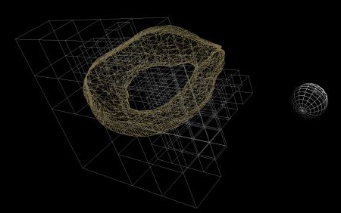
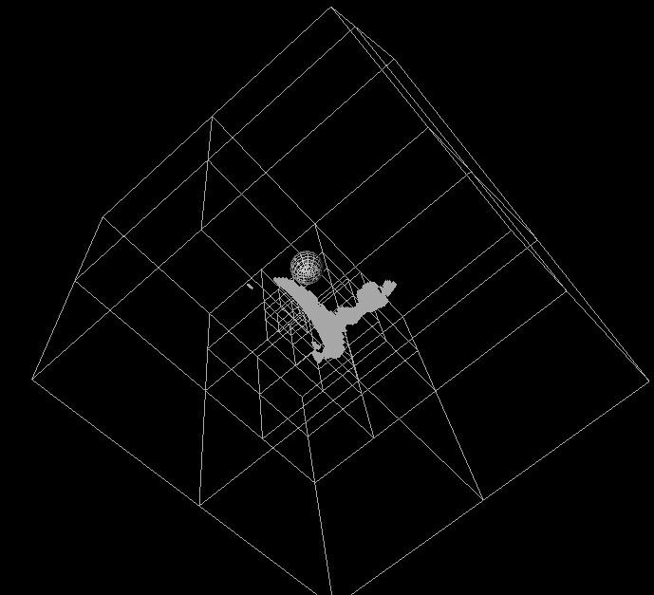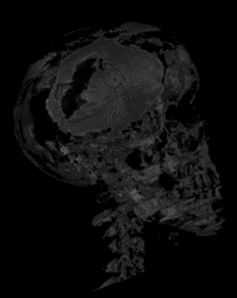Fig 4.10 Approximate implant from the 3D registration method (left) The Implant is binarized and represented using a multi resolution octree data structure (center), and sculpting is done with the defect embedded as a haptics cue (right)

Algorithm Sculpt(Cube, position_of_tool, center_of_cube, size_of_cube)

if(size_of_cube< min_resoution) and it is present in scene graph then

remove cube from scene graph

else if( size_of_cube> min_resolution) then

if(cube is not split) then

remove cube from scene graph

split into eight smaller cubes cube[1-8]and add them to scene graph

for each intersecting child cube

Call Sculpt(cube1, position_of_tool, center_of_cube, size_of_cube)

else if (cube already split)

for each intersecting child cube

Call Sculpt(cube1, position_of_tool, center_of_cube, size_of_cube)

end if

This algorithm is called once every update loop of the program. Due to the high frequency of the update loop very heavy work is avoided in the algorithm.

4.4.2 Addition tool

This tool is reverse of what the sculpting tool does and is used to add cubes of different resolutions based on the tool size. An Algorithm similar to the one written above is used for this tool. Instead of removing a cube when the resolution is reached a cube is added

4.4.3 Recording tool

One convenient thing about this algorithm is that it is based on the series of positions of the tool and its size. So the recording and repeating of user’s actions was conveniently done by saving the position, size of the tool at different instances of calling the algorithm. One such application is to use a 3D reverse marching Cubes action of converting the polygonal model to a 3D grid model [Huang98].

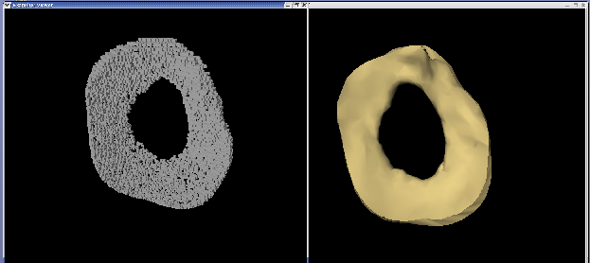

Fig 4.11 Recording used to reconstruct polygonal surface

A practical use of this is to try a simple way of converting the defect area into a 3D grid as shown above and subtract the same from a full 3D grid to get the actual implant. This however defeated the purpose of multi-resolution and was not suited for even moderately sized volumes and hence was not used as a method of implant generation.

4.4.4 Features

The sculpting tool and the addition tool needed some features so that the medical sculptor can use them efficiently. Predominant among them was the saving and retrieval of the sculpt file. This involves saving the scene graph of both Open Inventor and GHOST™. Open Inventor provides a convenient way of handling the saving of scene graphs and the haptic scene graph was built from the corresponding Open Inventor scene graph. Another important feature was the total reset of all operations i.e starting from scratch. This involves going down recursively done the octree and deleting all the child nodes. A third feature, which is more important from the efficiency point of view, is the rebuilding of the octree. Whenever a cube is split, sculpted, and then added again the parent node is checked if all the eight children are present and if so then the eight children are replace by a single parent node. This is very useful as the complexity of the scene graph especially that of GHOST™, is based on the number of objects.

4.5 Integration and pipeline

The last step in the process of implant generation is to use the two method described above – 3D registration and volume sculpting in tandem along a pipeline. The whole pipeline is described below. The process starts with the CT scanned images of the patient. The volume data is used in the 3D registration process and after thresholding and volume subtraction, an approximate implant is obtained. This implant is then fed into the sculpting and the addition tool. Modification of the implant is performed at this stage. The output of this stage is a implant which is a good fit for the defect. The output is converted to the STL (stereo-lithography) file format and fed into the rapid prototyping machines to get the actual implant. Figure 4.12 depicts the pipeline in a block diagram and figure 4.13 shows the different stages in the implant creation.
Raw Volume Data
Approximate Implant
Sculpting tool
Addition tool
Final
Implant
Patient
3D registration, subtraction
STL Format
Actual Implant
Rapid
Prototyping
Machines
Threshold, Binarize
CAT Scan

Fig 4.12 The Implant creation pipeline
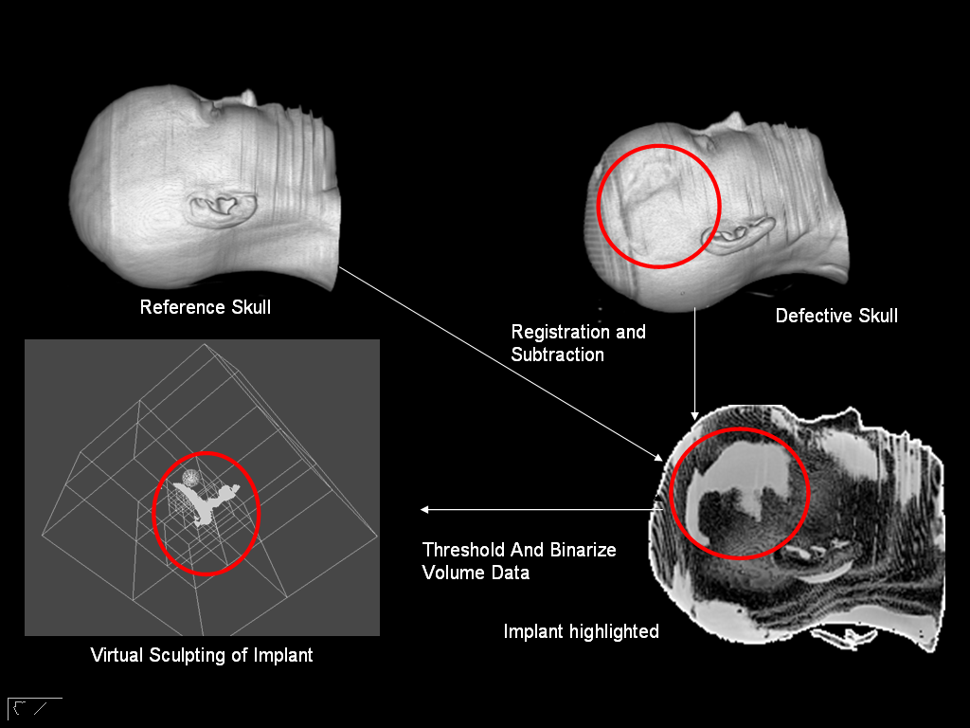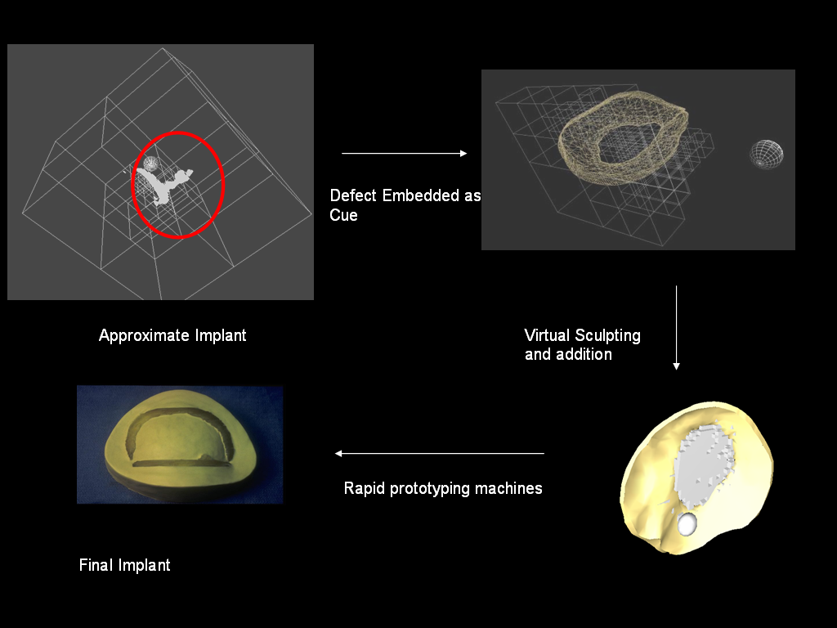

Fig 4.13 The Implant creation stages

The surgeon can create a number of these implants during pre-surgical analysis and try the best one for the patient during surgery. This way, much of the trial involving patients is eliminated, thereby expediting the process of implant creation. In addition the surgeon can also create different sets of implants to try out during the time of surgery with minimal additional cost. This is due to the fact that the implant is created virtually and also only part of the implant creation process need to be redone.

In this chapter the implementation details of the implant generation pipeline was dealt with. A method of 3D registration was used for the construction of the initial implant and this was fed as input to the sculpting tool. An octree based multi-resolution model was used in volume sculpting, which also allowed user to add and subtract volumes at different resolutions. The final model of implant is checked with the defect for a good fit and can send to the rapid-prototyping machines for getting the actual implant.

Chapter 5
Results and Discussion
This chapter analyses the results obtained from experiments and also provides some insight into the ways of extending the application to generate broader range of implants. This chapter also discusses about the other potential applications of the techniques used in this research work.

5.1. Results
The aim of this research work was to develop a method to create implant for cranial defects. In order to test the method, a human skull for which an implant had been previously created using the traditional technique was used. This was done so that the digital implant created can be easily evaluated.

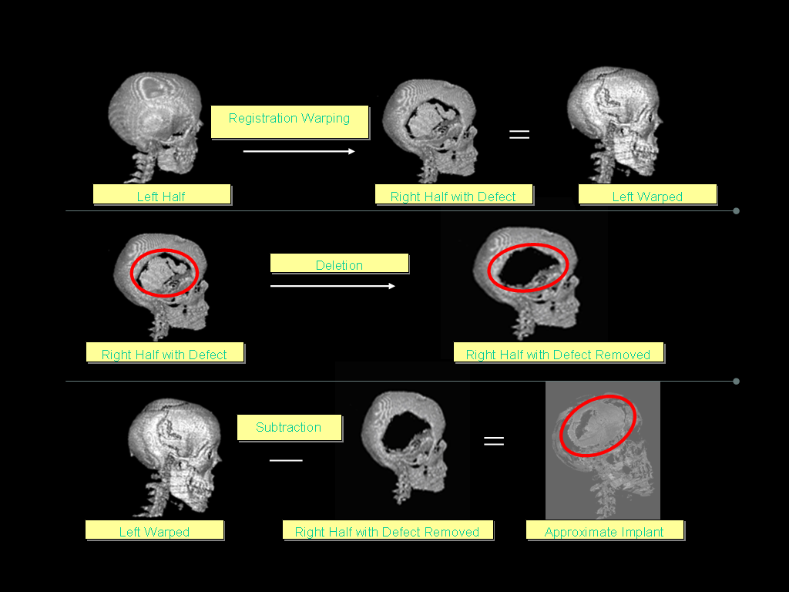

Figure 5.1 3D registration process

The skull has a defect in the right half as shown in figure 5.1 with a red outline, and the process of 3D registration and virtual sculpting produces and implant for that defect. The left half of the skull is registered with the right half of the skull as shown in the figure 5.1 using AIR (Automated Image Registration) and Analyze. In the second step the defect area is cleared, to get an implant that fills in the whole defect area. This step was done using Visualization toolkit (VTK). In the third step the volume subtraction is done so as to get the subtracted volume. This volume is then thresholded to obtain the approximate implant.
This is then converted into a binary volume and stored in a multi-resolution octree data structure, so that it can be sculpted. The next step uses the cranium editor application to generate the defect. This is done so that the defect can be embedded as a haptic cue during the virtual sculpting process. The sculpting process was done interactively in the PARIS™ using the PHANToM™ as a force feedback input device. Some of the operations that were supported were object manipulation, sculpting and addition. The output of this sculpting operation is a multi-resolution data structure consisting of cubes in open inventor format. This was then converted to the stereo lithography format (STL), for use in rapid prototyping machines, using VTK. The steps involved in the virtual sculpting process are shown in figure 5.2.

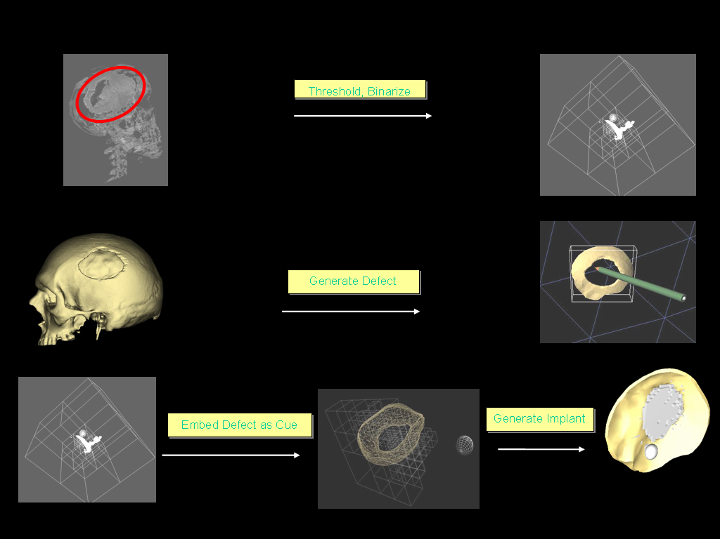

Figure 5.2 Virtual sculpting process

5.2 Discussions
The implant generation process is done in two steps as show in figure 5.1 and figure 5.2. The output of the 3D registration process for a sample volume file produced an implant with good curvature information. This was then converted into a data that can input to the virtual sculpting process. The sculpting process produced an implant with a good shape, with a error range of less than a millimeter. The implant generated from the virtual sculpting process is dependent on the 3D registration step for good shape information and hence the degree of precision of the implant was directly dependent on the 3D registration process.
The two step method also makes it feasible to use the pipeline to generate cranial implants for non-symmetric skulls. This is done by taking a sample skull, about the same dimensions of the skull with the defect, and makes use of that to generate the approximate implant. This way the shape and curvature information can be obtained even though the skull is not symmetric, which the 3D registration process requires. The virtual sculpting was tested by Dr. Zhuming Ai and Dr. Ray Evenhouse of the VR Med Lab, at the Bio-medical Health and Information Sciences Department, University of Illinois at Chicago. They gave good feedback on the process and felt that it was a vital part of the implant generation process.

5.3 Other Potential Applications
The general nature of the virtual sculpting tool makes it possible it use the same for other applications as well. Some of the potential ones include 3D modeling using haptic touch for creating models for games and also for designing objects in normal day to day use like shoes, cars etc. Also virtual sculpting could be used in other areas of medical fields like dental cavity filling and remote surgical applications. The workflow of most 3D application has the potential to become intuitive and faster when combined with haptics and hence virtual sculpting has significant role in above areas.

In this chapter the implants generated by the 3D registration and virtual sculpting processes were analyzed and also some methods of generating implants for wider cases of defects were discussed. Also some potential applications of virtual sculpting in other fields were discussed.

Chapter 6
Conclusions and Future Work

As computers have become increasingly sophisticated and powerful, there are many benefits to management and rectification of a wide range of patient conditions. Researchers are engaged in a number of innovative solutions that are designed to provide surgeons with the best possible information for both their education and to improve patient care. This application to generate the cranial implant using techniques in a virtual environment is a good step ahead in that direction. Developing the application for generating cranial implants, revealed several issues with both hardware and software. The issues which could not be dealt with are incorporated in the future work.

6.1 Lessons Learned
Some of the major hardware issues include the choice of haptic device and rendering paradigm, the immersive environment and the choice of tracking device. The different libraries that were used, the choice of data structure for storage, the sculpting algorithm and the 3D registration software and also the sculpting tools used were some of the software issues faced.

6.2 Hardware and software Issues
Since haptics is the sense of touch, the frequency of the servo loop had to be as high as 1000Hz to provide a seamless experience to the user. This meant that the amount of operations performed inside the servo loop has to be low and an application as intensive as sculpting needs to be a low key process. This was the first big challenge in application development. As a result, the number of objects in the scene has to be a minimum, and a data structure which optimizes the storage was required. Also since the implant needed to be precise shape, and should have the correct curvature, a pre-processing stage to the sculpting process was needed to generate the approximate implant. Moreover the implant generation technique must follow the same workflow as the traditional technique, so that the sculptors and surgeons find it intuitive.
The head and the hand are both tracked using magnetic trackers, which needs to stay away from the sensor unit to avoid tracking from being negated by interference. The size of the skull data that can be sculpted is limited by the amount of data that the device can handle which was found to be a 256 millimeter cube. When the number of objects in the scene increased, the servo loop crashed, thereby stalling the application. A bad 3D registration produces a difference volume with two layers and hence makes the approximate implant unusable. The final implant generated has some corrugated edges due to the sculpting process and this need to be smoothened.

6.3 Future Research
Full effectiveness of the application cannot be done without trying out the implant on the patient. The size limitation of a 256 cube, in the current volume sculpting technique must be dealt with. Developing tools for the implant generation, other than the sculpting and addition process, is one of the major additions that need to be done. An algorithm for generating a smoother implant is really desirable feature.
As part of a three year research grant, evaluation will compare digital models of implants against the traditionally constructed models. Another important feature is to procure a new PARIS™ with tracking and network with other PARIS™ or immersive display systems. Parallelizing the sculpting process is one of the major issues that need to be addressed. Open haptics toolkit developed by SensAble technologies Inc, is a library that needs to be investigated more for usage in this application. The use of volume sculpting directly on the volume data using a proxy point to move along the surface is another approach to volume sculpting that can be investigated into for a faster approach and the open haptics toolkit is more suited for this.
In this chapter the lessons that were learned during the course of this research, hardware and software issues faced were discussed. The final section dealt with directions for future research in this work.

Bibliography

[AANS99] American Association of Neurological Surgeons: Top reported cranial procedures performed in 1999, 1999.

[Akermann95]Akermann, M.: The visible human project, 1995.
[Avila96]Avila, R., and Sobierajski, L.: A haptic interaction method for volume visualization, IEEE Conference on Visualization, pp. 197-204, 1996.

[Ayasse01]Ayasse, J., and Mueller, H.: Interactive manipulation of voxel volumes with free-formed voxel tools: Vision Modeling and Visualization, pp. 359-366, 2001.

[Azuma97 ]Azuma, R.: A survey of augmented reality. presence: Teleoperators and Virtual Environments Vol. 6 , pp. 355-385 , 1997.

[Baerentzen99]Baerentzen, J.: Octree-based volume sculpting: Procof IEEE Visualization, pages 9–12, 1998.

[Bibb02] Bibb, R., Bocca, A., and Evans, P.: An appropriate approach to computer aided design and manufacture of cranioplasty plates: Journal of Maxillofacial Prosthetics & Technology, Vol. 5, 2002.

[Bloomenthal01] Bloomenthal, J.: Implicit surfaces: Encyclopedia of Computer Science and Technology, Vol. 44, pp. 227-257, 2001

[Bloomenthal90]Bloomenthal, J., and Wyvill, B.: Interactive techniques for implicit modeling: ACM Transactions on Computer Graphics, Vol. 24, pp. 109-116, 1990.

[Bloomenthal89] Bloomenthal, J.: Techniques for Implicit Modeling: Proceedings of the symposium on Interactive 3D graphics, 1990.

[Boyles01]Boyles, M., and Fang, S.: 3DIVE: An immersive environment for interactive volume data exploration: 7th International Conference on CAD/Graphics, pp. 573-580, 2001

[Bremer01]Bremer, P., Porumbescu, S., Kuester, F., Hamann, B., Joy, K., and Ma, K.: Virtual clay modeling using adaptive distance fields: UC Davis Student Workshop on Computing, 2001

[Burdea00]Burdea, G.: Haptic issues in virtual environments: IEEE Computer Graphics International, pp. 295-303, 2000

[Burgert03]Burgert, O., Seifert, S., Salb, T., Gockel, T., Dillmann, R., Hassfeld, S., and Muehling, J.: A VR-system supporting symmetry related cranio-maxillofacial surgery: Medicine Meets Virtual Reality Vol. 94, pp. 33-35, 2003.

[Chai98]Chai, V., Luecke, G., and Edwards, J.: Virtual clay modeling using the isu exoskeleton: IEEE Virtual Reality Annual International Symposium, 1998.

[Chen99]Chen, E.: Six degree-of-freedom haptic system for desktop virtual prototyping applications: International Workshop on Virtual Reality and Prototyping, pp. 97-106, 1999

[Coin3d] Coin3D Motion, S.i.

[Cruzneira93]Cruz-Neira, C., Sandin, D., and DeFanti, T.: Virtual Reality: The design and implementation of the CAVE: Proceedings of the SIGGRAPH Computer Graphics Conference, pp. 135-142, 1993

[Deisinger00]Deisinger, J., Blach, R., Wesche, G., Breining, R., and Simon, A.: Towards immersive modeling - challenges and recommendations: A Workshop Analyzing the Needs of Designers EuroGraphics Conference of Virtual Environments, 2000

[Dujovney99] Dujovney, M., Evenhouse, R., Agner, C., Charbel, L., Sadler, L., and McConathy, D. Performed prosthesis from computer tomography data: Repair of large calvarial defects pp. 77- 88, 1999

[Eric03]He, E., Alimohideen, J., Eliason, J., Krishnaprasad, N., Leigh, J., Yu, O., DeFanti, T.: Quanta: A toolkit for high performance data delivery over photonic networks: Journal of Future Generation Computer Systems (FGCS), Elsevier Science Press, Volume 19, Issue 6, August 2003.

[Ferley99]Ferley, E., Cani, M., and Gascuel, J.: Practical volumetric sculpting: Proceedings of Implicit Surface, 1999.

[Ferley02]Ferley, E., Cani, M., and Gascuel, J.: Reoslution adaptive volume sculpting graphical models (GMOD), Volume 63, pp 459-478 - March 2002.

[Foley00]Foley, J.: Getting There: the top ten problems left: IEEE Computer Graphics and Applications, 2000

[Frisken00]Frisken, S., Perry, R., Rockwood, A., and Jones, T.: Adaptively sampled distance fields: A general representation of shape for computer graphics: ACM SIGGRAPH, pp. 249-254, 2000.

[Gain96]Gain, J.: Virtual sculpting: an investigation of directly manipulated free-form deformation in a virtual environment: Rhodes University, 1996.

[Galyean91]Galyean, T., and Hughes, J.: Sculpting: An interactive volumetric modeling technique. ACM SIGGRAPH, 1991.

[Gamma95]Gamma, E., Helm, R., Johnson, R., and Vlissedes, J.: Design Patterns: elements of reusable object-oriented software: Addison-Wesley, 1995.

[Gibson97]Gibson, S., Fyock, C., Grimson, E., Kanade, T., Kikinis, R., Lauer, H., McKenzie, N., Mor, A., Nakajima, S., Ohkami, H., Osborne, R., Samosky, J., and Sawada, A.: Simulating surgery using volumetric object representations: Medical Image Analysis, pp. 121-132, 1997.

[Hesina99]Hesina, G., Schmalstieg, D., Furhmann, A. and Purgathofer, W.: Distributed open inventor: a practical approach to distributed 3d graphics: ACM Symposium on Virtual Reality Software and Technology, pp. 74-81, 1999.

[Hinkley94]Hinkley, K., Pausch, R., Goble, J., and Kassell, N.: A survey of design issues in spatial input: ACM Symposium on User Interface Software and Technology, pp. 213-220, 1994.

[Hirota95]Hirota, K., and Hirose, M., Providing force feedback in virtual environments: IEEE Computer Graphics and Applications, Vol. 15, pp. 22-30, 1995.

[Hirota00]Hirota, K., Tanaka, A., Hirose, M., and Koneko, T.: Shape forming by cutting and deforming operations: International Conference on Artificial Reality and Tele-existence, 2000.

[Hollerbach00]Hollerbach, J.: Some current issues in haptics research: IEEE Conference on Robotics and Automation, pp. 757-762, 2000.

[Huang98]Huang, J., Yagel, R., Filippov, V., and Kurzion, Y.: An accurate method for voxelizing polygon meshes. IEEE Conference on Visualization, pp. 119-126, 1998.

[Jagnow02]Jagnow, R., and Dorsey, J.: Virtual sculpting with haptic displacement maps: Proceedings of Graphics Interface May 2002.

[Johnson00]Johnson, A., Sandin, D., Dawe, G., DeFanti, T., Pape, D., Qiu, Z., Thongrong, S., and Plepys, D.: Developing the PARIS: using the CAVE to prototype a new VR display:
ACM Symposium on Immersive Projection Technology, 2000

[Johnson98]Johnson, D., and Cohen, E.: A framework for efficient minimum distance computations: Proceedings of IEEE International Conference on Robotics and Automation, Leuven, Belgium, May 16-21, pp. 3678-3684, 1998.

[Kameyama97]Kameyama, K.: Virtual clay modeling system: ACM Symposium of Virtual Reality Software and Technology, pp. 197-200, 1997.

[Keeve96]Keeve, E., Girod, S., Pfeifle, P, and Girod, B.: Anatomy-based facial tissue modeling using the finite element method: IEEE Proceedings of 7th Conference on Visualization, 1996.
[Kling-petersen00]Kling-Petersen, T., and Rydmark, M.: Modeling and Modification of medical 3d objects. the benefits of using a haptic modeling tool: Medicine Meets Virtual Reality, 2000
[Lee02 Lee, H., Lee, J., and Yang, H.: Realtime LOD Marching cube and octree based object lod modeling: Virtual Reality Research Center, 2003.

[Leigh97]Leigh, J., Johnson, A., and DeFanti, T.: CAVERN: A distributed architecture for supporting scalable persistence and interoperability in collaborative virtual environments: Virtual Reality Research Development and Applications, Vol. 2, pp. 217-237, 1997.

[Li01]Li, F., Lau, R., and Nag, F.: Collaborative distributed virtual sculpting: IEEE Virtual Reality 2001.

[Lin00]Lin, M., Ehmann, S.: Interactive multiresolution modeling and 3d painting with a haptic interface: Proc. IEEE Virtual Reality Conference, March 2000, 45–52.

[Lorenson87] Lorensen, L., and Cline, H.:Marching Cubes: A High Resolution 3D Surface Construction Algorithm: Computer Graphics (Proceedings of SIGGRAPH '87), Vol. 21, No. 4, pp. 163-169, 1997.

[Lu02] Lu, Y., Wang, W., Liang, R., and Ouhyoung, M.: Virtual sculptor: A feature preserving haptic modeling system: Proc. of ACM International Workshop on Immersive Telepresence, 2002.

[Marchesin04] Marchesin, S., Dichler, S., and Mongeneta, C.: 3D ROAM for scalable volume visualization: Proceedings of IEEE Visualization 2004.

[Massie98]Massie, T.: Tangible goal for 3D modeling: IEEE Computer Graphics and Applications , Vol. 18, pp. 62-65, 1998

[Mcdonnell01] Virtual Clay: A Real-time sculpting system with haptic toolkits McDonnell, K.; Qin, H. Wlodarczyk, R. ACM Symposium on Interactive 3D Graphics, pp. 179-190 , 2001

[Meagher82]Meagher, J.: Geometric modeling using octree encoding: Computer Graphics and Image Processing, 19:129-147, 1982.

[Nishino99]Nishino, H., Utsumiya, K., Korida, K., Sakamoto, A., and Yoshida, K.: A method for sharing interactive deformations in collaborative 3D. ACM Symposium on Virtual Reality Software and Technology , pp. 116-123 , 1999.

[Novint01]e-Touch Novint Technologies 2001 http://www.etouch3d.org/

[Park00]Park, K., Cho, Y., Krishnaprasad, N., Scharver, C., Lewis, M., and Leigh, J.: CAVERNsoft G2: A toolkit for high performance tele-immersive collaboration: ACM Symposium on Virtual Reality Software and Technology, pp. 8-15, 2000.

[Perry01]Perry, R., and Frisken, S.: Kizamu: a system for sculpting digital characters: Proceedings of ACMSIGGRAPH, pages 9–12, 2001.

[Potts00]Potts, A.: Phantom-based haptic interaction, 2000.

[Rajlich]Rajlich, P.: vtkActorToPF. www.kitware.com

[Roettger03]Roettger, S., and Ertl, T.: Fast volumetric display of natural gaseous phenomena: Proccedings of Computer Graphics International, 2003.

[Rohlf94] Rohlf, J., and Helman, J.: IRIS performer: a high performance multiprocessing toolkit for real- time 3D graphics: ACM SIGGRAPH Special Interest Group on Computer Graphics and Interactive Techniques pp. 381-394, 1994.

[Ruspini97]Ruspini, D., Krasimir, Kolarov., and Khatib, O.: The haptic display of complex graphical environments: ACM SIGGRAPH Special Interest Group on Computer Graphics and Interactive Techniques, 1997.

[Salisbury97]Salisbury, J., and Srinivasan, M.: Phantom-Based haptic interaction with virtual graphics.

[Scharver04a] Scharver, C., Evenhouse, R., Johnson, A., and Leigh, J.: Designing cranial implants in a haptic augmented reality environment: Communications of the ACM , Vol. 47 , pp. 32-38 , 2004.

[Scharver04b] Scharver, C., Evenhouse, R., Johnson, A., and Leigh, J.: Pre-surgical cranial implant design using the PARIS prototype: Proceedings of the IEEE Conference on Virtual Reality , pp. 199-206, pp. 32-38 , 2004.

[Sensable99] FreeformTM modelingsystem: SensAble Technologies, Inc, 1999.
[Sensable01] GHOST SDK: SensAble Technologies, Inc, 2001.
[Tgsopeninventor] TGS Open Inventor Inc.: T.G.S.

[Tgs02] TGS Open Inventor 3.1 User's Guide: TGS, I. 2002

[Vallino99]Vallino, J., and Brown, C.: Haptics in augmented reality: IEEE International Conference on Multimedia computing and Systems, Vol. 1 , pp. 9195 , 1999.

[VTK03] Schroeder, W., Martin,K., and Lorensen, B.: The visualization toolkit an object-oriented approach to 3d graphics: Kitware, Inc., 2003.

[Taha01]Taha, F., Testelin, S., Lengele, B., and Boscherini, D.: Modeling and design of a custom made cranium implant for large skull reconstruction before a tumor removal, 2001

[Wang95]Wang, S., and Kaufman, A.: Volume sculpting: Proceedings of ACM Symposium on Interactive 3D Graphics, pages 151–156, 1995.
[Wong00]Wong, J., Lau, R., and Ma, L.: Virtual 3D sculpting: Journal of Visualization and Computer Animation, 2000.
[Wernecke94]Wernecke, J.: The Inventor Mentor: Programming object-oriented three dimensional graphics with open inventor, Release 2: Addison-Wesley Publishing, 1994.

[Wilhems00]Wilhelms, J., and Gelder, A.: Octrees for faster isosurface generation: ACM Transactions on Graphics, Vol. 11pg. 201--227. 1992.

[Zhou97]Zhou, Y., Chen, B., and Kaufman, A.: Multiresolution tetrahedral framework for visualizing regular volume: IEEE Visualization Proceedings of the 8th conference on Visualization 1997.

[Zilles95]Zilles, C., and Salisbury, J.: A constraint-based god-object method for haptic display: Proceedings of the International Conference on Intelligent Robots and Systems 1995.

Appendices

Appendix A
LIST OF ABBREVIATIONS

2D Two dimensional
3D Three Dimensional
AIR Automated Image Registration
API Application Programming Interface
AR Augmented Reality
CAD Computer- Aided Design
CAM Computer- Aided Manufacturing
CAVE CAVE Automatic Virtual Environment
CSG Computational Solid Geometry
CT Computed Tomography
CVE Collaborative Virtual Environment
DICOM Digital Imaging and Communications in Medicine
DOF Degrees of Freedom
EVL Electronic Visualization Laboratory
FEM Finite Element Method
GHOST General Haptics Open Software Toolkit
GUI Graphical User Interface
IP Internet Protocol
MRI Magnetic Resonance Imaging
NURBS Non-Uniform Rational Beta Splines
OIV Open Inventor
PARIS Personal Augmented Reality Immersive System
PET Positron Emission Tomography
SDK Software Development Kit
STL Stereo lithography format
UCLA University of California at Los-Angles
UIC University of Illinois at Chicago
VE Virtual Environment
VR Virtual Reality
VRML Virtual Reality Modeling Language
VTK Visualization toolkit

Appendix B

Building the Project

The project has been built using several different libraries that provide graphics, haptics and registration capabilities. The libraries and their versions are as follows

CAVELib 3.1.1

Coin3D 2.3.0 with thread safety enabled

GHOST 4.0

QUANTA 0.4

VTK 4.5

AIR 5.1

Analyze 6.0

These libraries should be installed and available to the compiler. The source has been tested on Windows 2000 with Visual studio 6, Red Hat 9.0 with GCC 3.3. The source code configures suing CMake. The steps involved in creation of implant are give below

Generate two halves of the skull and register the same using AIR 5.0 and Analyze 6.0

3D Subtraction process using VTK.

Threshold and binarize the approximate implant

CrEdit to generate defect in PARIS™

Sculpting system with defect embedded as the haptic cue

